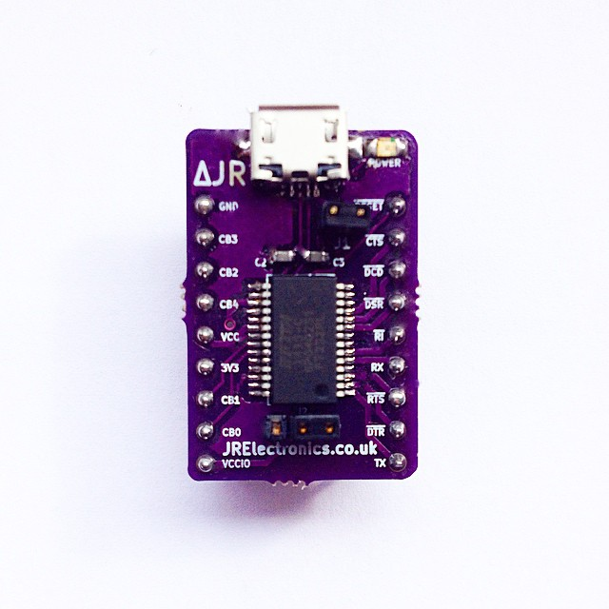
JR Electronics
#JR1403
JR 232micro Module
Rev. 1.0

Introduction

JR Electronics introduces the JR 232micro Module - a diverse and easy to use USB to UART interface. The JR 232micro module utilises FTDI Chip’s FT232R Chip. The device has the ability to provide USB to full handshake UART communication. It also has the added benefits of configurable I/Os with options for bitbang (sync or async), external clock output for driving microcontrollers or FPGAs (6MHz/12MHz/24MHz/48MHZ), can be used to power external circuitry (500mA @ 5V / 50mA @ 3V3) and a host of other very useful features.
For more information on the IC, click the link below;
http://www.ftdichip.com/Support/Documents/DataSheets/ICs/DS_FT232R.pdf

Contents
Introduction 1
Typical Application 4
Driver download and installation 6
Programming the Device 7
Dimensions 10
Module Schematic 12
Summary of Use 13

Typical Application
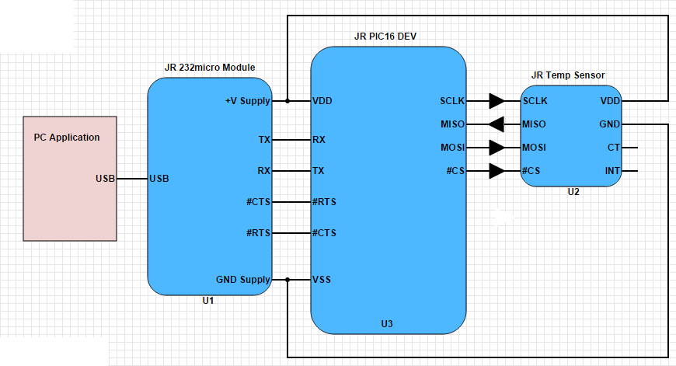
Above is a basic diagram of how to connect the JR 232micro Module. Note that RTS and CTS connections are optional but are recommended for higher baud rates.
This example application uses the JR Temp Sensor module to take temperature readings. The results of these readings are then read by the JR PIC16 Dev board via SPI (serial peripheral interface). Once this is done, the microcontroller can pass these readings into the TX register to be sent over USB to a custom PC application where there is a real time temperature Vs time graph being plotted.
This is a simple example on how to use the JR 232micro module. It could be used with level shifters to provide a true RS232/RS485 to USB converter.

To view and download example programs for the JR 232micro Module, head to the software and firmware section of our website!

Driver download and installation

To use the JR 232micro Module, you must download FTDI’s royalty free drivers. The drivers can be downloaded from here;
http://www.ftdichip.com/FTDrivers.htm

FTDI offer two different types of driver, Virtual COM Port (VCP) drivers and direct (D2XX) drivers. The VCP driver emulates a standard PC serial port. Using this with the JR 232micro Module allows it to be communicated with as a standard RS232 device. If you’re a beginner or a student, don’t worry – it’s easier than it sounds.
The D2XX driver allows direct access to the JR 232micro Module via a DLL interface. If using the D2XX driver, the D2XX Programmer’s Guide from FTDI will be invaluable – this can be obtained from here;
http://www.ftdichip.com/Support/Documents/ProgramGuides/D2XX_Programmer's_Guide(FT_000071).pdf

Programming the Device

The JR 232micro module, by default, will be limited to draw upto 90mA from the USB port. This can be changed to anything up to 500mA using FTDI Chip’s free programming utility – FT PROG.
FT PROG can be found here;
http://www.ftdichip.com/Support/Utilities.htm
Once the device enumerates and is visible, you can scan for devices using the icon. This will open the device where you can change the maximum bus power to the device;
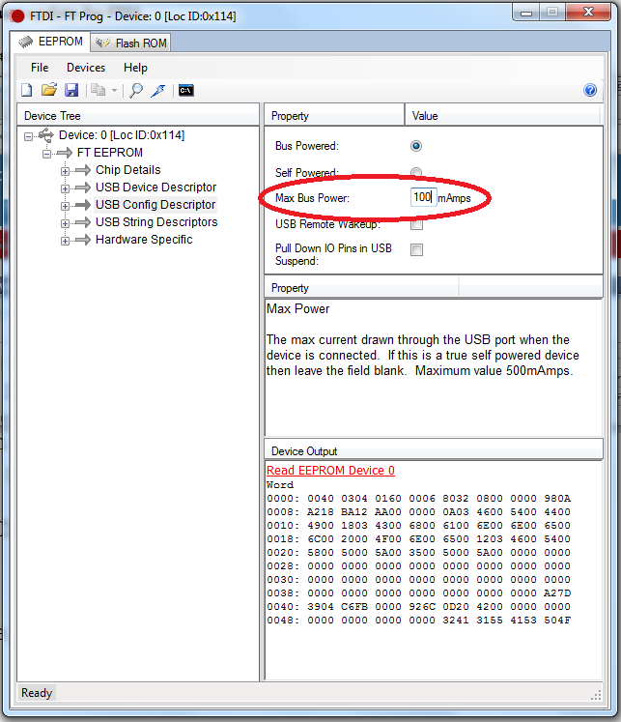

Once you have edited the Max Bus Power field, click the button to program the device.
Your device is now programmed with your new bus power and is ready to go.
FT PROG can also be used to change the device descriptors, allowing you to change how the device appears when it is plugged in to the PC.

Dimensions
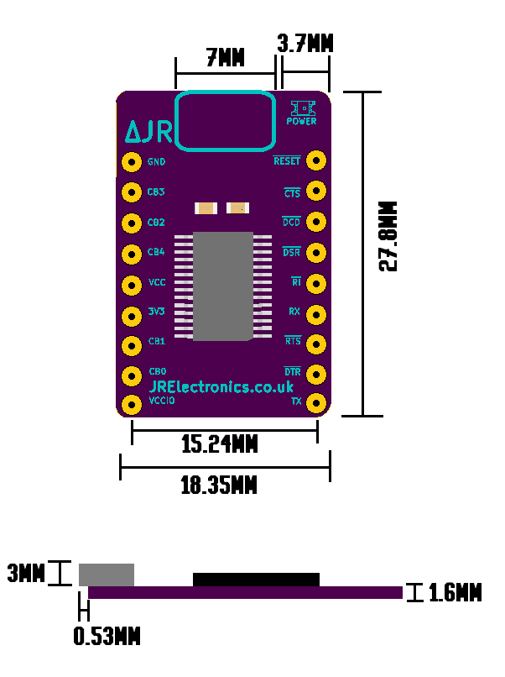
Notes:
The pin spacing for this device is the standard 0.1” (2.54mm) and the spacing between each row is 15.24mm – which is perfect for prototyping with a breadboard.

Jumper Configuration:
With J1 closed, the device is powered from the VBUS and is bus powered. With J1 open, the device can be powered from an external power source.

With J2 connected to pin 1 & 2, the I/O level is 5V. With J2 connected to pin 2 & 3, the I/O level will be 3V3.

Module Schematic
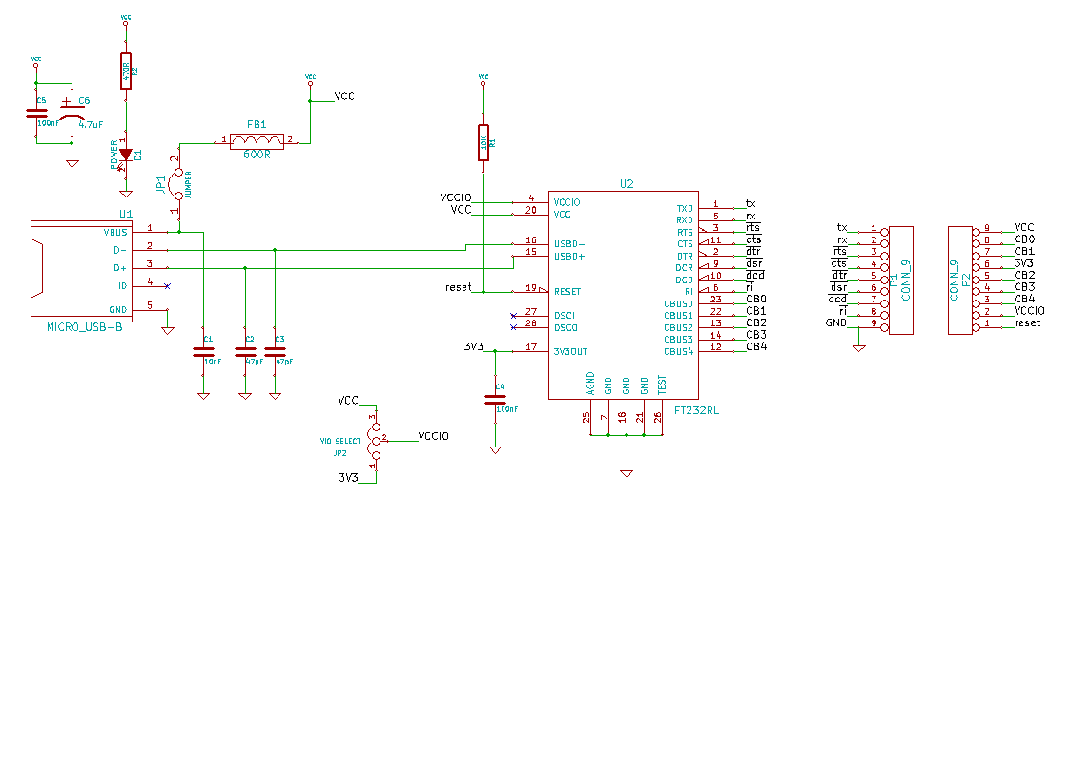

Summary of Use

To summarise setting up and beginning to use your device;
- Download FTDI Chip’s Drivers from here;
http://www.ftdichip.com/FTDrivers.htm
- If your device will draw more than 100mA, download FT_PROG here;
http://www.ftdichip.com/Support/Utilities.htm
Then change Max Bus Power field to your desired level and program the device.
- Connect your JR 232micro Module to your microcontroller and you’re ready to start transmitting and receiving data. Just download a serial port emulator like our JR Electronics Module Tester from our website and you’re ready to go!

If you have any questions or need any support, don’t hesitate to email us at enquiries@jrelectronics.co.uk
Be sure to check out the example code on our website!

Thank you for using JR Electronics!

