JR Electronics
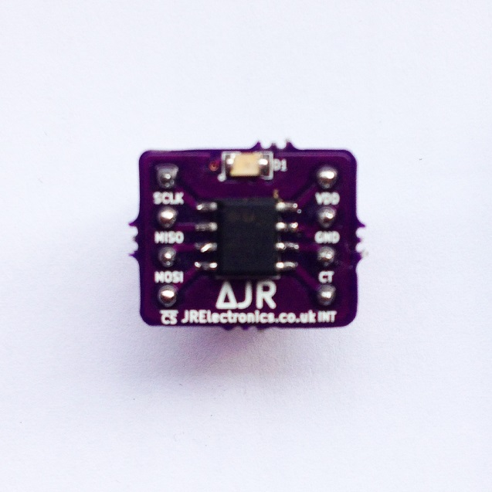
#JR1408
JR Temp Sensor Module
Rev. 1.0

Introduction

JR Electronics introduces the JR Temp Sensor Module – an accurate, easy to use digital temperature sensor.
The JR Temp Sensor Module utilises Analog Devices’ ADT7310 IC. By default, the device has a 13-bit ADC to monitor and digitize the temperature to a resolution of 0.0625⁰C. This can be changed to a 16-bit reading, giving a resolution of 0.0078 °C.
The device has an SPI interface for communicating with the device and comes complete with power LED, pull-up resistors and a supply decoupling capacitor.
For more information on the IC, follow the link below;
http://www.analog.com/static/imported-files/data_sheets/ADT7310.pdf

Contents
Introduction 1
Typical Application 4
Writing to the device 6
Reading from the device 7
INT and CT pins 9
Dimensions 10
Module Schematic 11
Summary of use 12

Typical Application
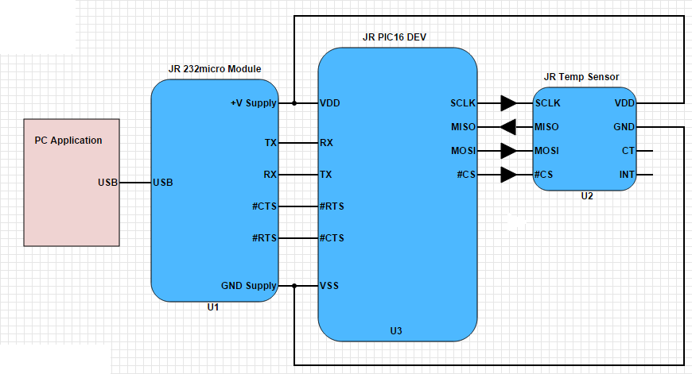

Above is a basic diagram of how to connect the JR Temp Sensor Module.
This example application uses the JR Temp Sensor module to take temperature readings of the ambient temperature. The results of these readings are then read by the JR PIC16 Dev board via SPI (serial peripheral interface). Once this is done, the microcontroller can pass these readings on to the JR 232micro module to be sent over USB to a custom PC application where there is a real time temperature Vs time graph being plotted.
In normal mode, the temperature sensor is in ‘continuous conversion’ mode where once one conversion completes, another is started straight away. The data read from the sensor is in 13-bit or 16-bit resolution but bits can be ignored to give a simple 8-bit resolution. See the datasheet for more information;
http://www.analog.com/static/imported-files/data_sheets/ADT7310.pdf

To view and download example programs for the JR Temp Sensor Module, head to the software and firmware section of our website!

Writing to the device

The simplest method of communicating with the device is to use the JR Temp Sensor module in its default configuration – 13-bit resolution/continuous conversion mode.

This is done as follows;

- After power-up, perform a reset by sending 32 consecutive 1’s to the microcontroller.
- Take #CS low (acts as frame synchronization signal).
- Data is clocked into the temperature sensor on the rising edge of SCLK.
- Hold MOSI (Master Out-Slave In) low to stop temperature sensor for resetting.
- Send Command Byte to microcontroller.
- Data can then be written to/read from the intended register.
- Take #CS high to end transaction.

Note: it is recommended that SCLK idle high between data transfers.
The ADT7310 datasheet should be referenced when writing firmware for your device.

Reading from the device

A read transaction is initiated when the master sends a command byte with the read/write bit set to ‘1’.
The master then supplies 8 or 16 SCLK pulses (depending on the addressed register) to read the data on the MISO pin.
Data is clocked out of the JR Temp Sensor Module on the first falling edge of SCLK.

Below is a brief algorithm for reading from the JR Temp Sensor Module in 13-bit Continuous Conversion Mode;
- After power-up perform a device reset by sending 32 consecutive ‘1’s to the device.
- Take #CS Low (acts as a frame synchronization signal).
- Send command byte 0x54 to the device to enter continuous conversion mode.
- Hold MOSI low to stop the device from resetting.
- Send 16 SCLK pulses and read each bit from MISO pin.
- You have your temperature result and now the data can be formatted and sent to your custom PC application via USB.
There is more to this than is documented in the brief algorithm. Head to the ADT7310 Datasheet for timing requirements, command bytes and temperature data formats;
http://www.analog.com/static/imported-files/data_sheets/ADT7310.pdf

INT and CT pins

The INT pin is an open drain overtemperature and undertemperature indicator and the CT pin is an open drain critical overtemperature indicator.
The default configuration on power-up is set so that if the temperature exceeds 64°C, the INT pin asserts low and if the temperature exceeds 147°C, the CT pin asserts low.
For more information on modifying the INT and CT set points, view the ADT7310 datasheet;
http://www.analog.com/static/imported-files/data_sheets/ADT7310.pdf

Dimensions
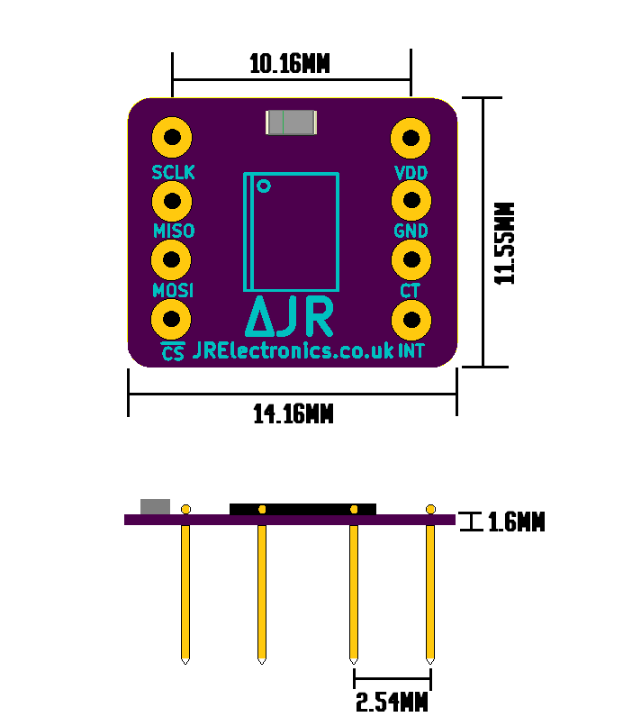Note: The pin spacing for this device is the standard 0.1” (2.54mm) and the spacing between each row is 10.16mm – which is perfect for prototyping with a breadboard.

Module Schematic
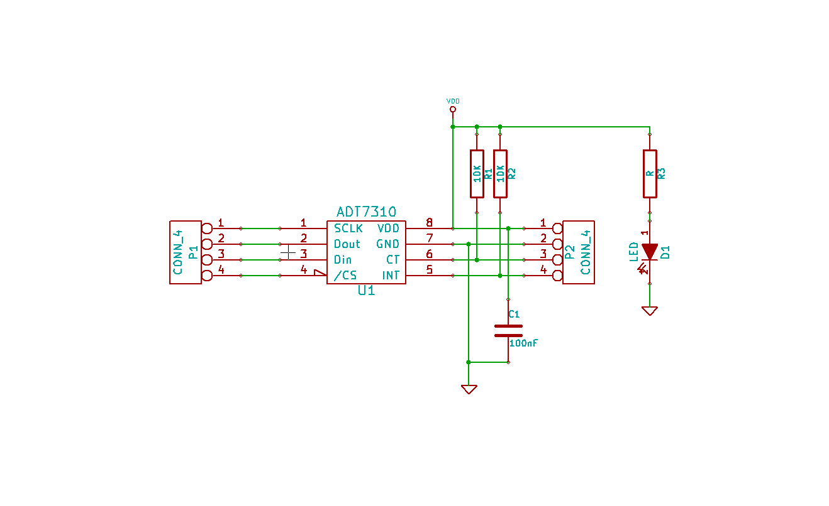

Summary of use

To summarise setting up and beginning to use your device;
- Power up device
- Perform reset
- For normal and easiest use, send command byte 0x54 to enter continuous conversion mode
- Hold MOSI low to stop device from resetting
- Send 16 dummy clock cycles to read 13-bit conversion
- Use a JR Electronics microcontroller breakout board and a JR Electronics USB to UART module to send to custom PC application (optional)

If you have any questions or need any support, don’t hesitate to email us at enquiries@jrelectronics.co.uk
Be sure to check out the example code on our website!

Thank you for using JR Electronics!

