WS2803 SOP28 PINS AND Jump Wire Change
Original Package:
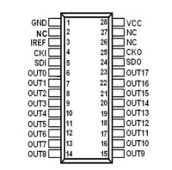
Current Package：
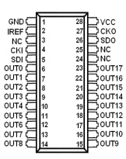
You can see that the PIN-2 and PIN-3 are opposite,the original 24 PIN move to 26PIN,original 25 PIN moves to 27 Pin.

So the jump wire can short PIN-3 and PIN-3,PIN-24 Jump to PIN-26,PIN-25 Jump to PIN-27.

