Quick Start Guide: Self Adjusted DST Clock System
  - Set Up, Wi-Fi Configuration, and Remote Pairing Made Easy

1. Getting Started
Plug your Clock Gateway into a power outlet using a certified USB to AC power adapter or any available USB port. The red LED will light up. After a few seconds, a blinking blue LED means it's ready for setup.
Connect your smartphone or computer to the “Clock_Gateway” Wi-Fi network. If a captive portal does not appear, scan the provided QR code or open your browser and visit 191.168.4.1.
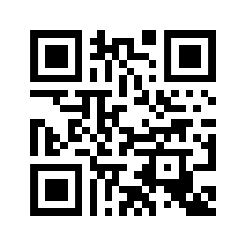
Select your home Wi-Fi network from the drop-down menu, enter your password, and click Submit. The blue LED will turn solid, indicating the Gateway is connected.
Install the clock movement and hands, set the current time using the knob, and insert a new AA battery. The clock will begin operating and communicate with the Gateway every 30 seconds. Your clock is now ready to automatically adjust for DST changes.

2. Changing Gateway Wi-Fi Settings
To change the Wi-Fi network or password, unplug the Gateway for 10 seconds and plug it back in. Use a sharp tool to press the button below the red LED within the first 3 seconds. The blue LED will blink, indicating programming mode. Repeat the setup steps above to reconnect to a new network.

3. Pairing the Gateway with a Handheld Display
Enhance your system by pairing a handheld Display (available separately - https://www.tindie.com/products/ses/display-to-control-self-adjusted-dst-clocks/) to monitor battery status and control clocks remotely.
- Charge the Display using a certified USB to AC power adapter or USB port.
- Open the Display’s configuration screen via the Gear icon.
- Select the Wi-Fi network used for the Gateway, enter the password, and enable Wi-Fi (slide switch turns green).
- Note the Display’s pairing code (XX:XX:XX:XX:XX:XX).
- Unplug and plug back the Gateway, then use a sharp tool to press the button below the red LED within 3 seconds to enter programming mode (blue LED blinks).
- Reconnect via smart phone or computer to “Clock_Gateway” Wi-Fi network, access the portal, and note the Gateway’s pairing code (YY:YY:YY:YY:YY:YY).
- Enter the Display’s code into the Gateway portal* and the Gateway’s code into the Display’s configuration screen.
Once paired, you can control and monitor your clocks remotely.

* make sure to select again the Wi-Fi network and enter password on the gateway portal before submitting.

