**SKU List**

A:Maker-esp32-pro

B:Maker-esp32-pro + Building Block Shell

C:Maker-esp32-pro + 18650 Battery Module (including battery) + Four Encoder Motors

D:Maker-esp32-pro Main Board + 18650 Battery Module (including battery) + Four Motors

E:Maker-esp32-pro Main Board + 18650 Battery Module (Including Battery)

F:Maker-esp32-pro Main Board + PS3 Gamepad

G:Maker-esp32-pro Main Board + PS3 Gamepad + 18650 Battery Module (Excluding Battery)

H:Maker-esp32-pro Main Board + PS3 Gamepad + 18650 Battery Module (Including Battery)

I:Maker-esp32-pro Main Board + PS3 Gamepad + 18650 Battery Module (Including Battery) + Four Encoder Motors

J:Maker-esp32-pro Main Board + PS3 Gamepad + 18650 Battery Module (Including Battery) + Four Motors

**Brief introduction**

MAKER-ESP32-PRO is a signature product for maker education developed based on Espressif Systems' ESP32-WROOM-32 module, featuring 4MB Flash and a single-chip solution integrating 2.4 GHz Wi-Fi + Bluetooth dual-mode.

Onboard, it supports 4-channel encoder motors and DC motors with a maximum driving current of 3A. The encoder/DC motors share the same driver pins—the same port cannot drive encoder and DC motors simultaneously.

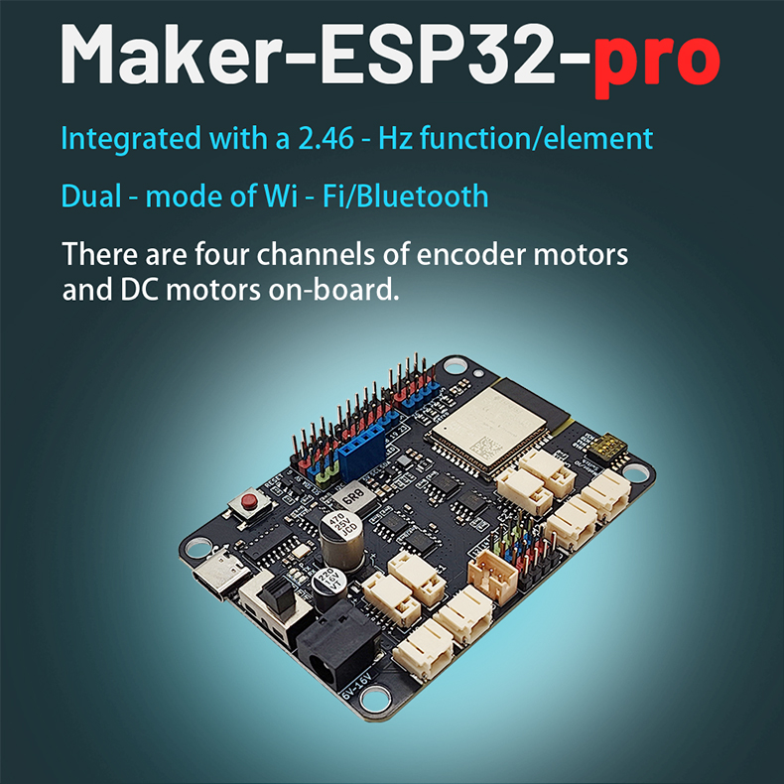

**Technical specifications**

Specifications of the Module Used in MAKER-ESP32-PRO

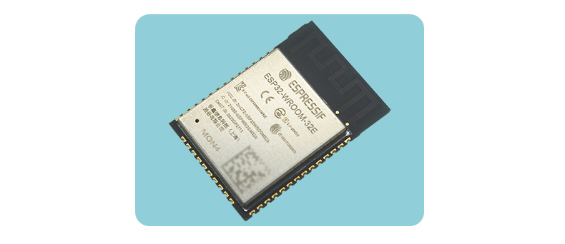

* 448 KB ROM, 520 KB SRAM, 16 KB RTC SRAM
* QSPI supports multiple flash/SRAM.
* Built - in 8 MHz oscillator.
* Supports self - calibration.
* Built - in RC oscillator, supporting self - calibration.
* Supports an external main crystal oscillator ranging from 2 MHz to 60 MHz (Currently, only a 40 MHz crystal oscillator is supported if Wi - Fi/Bluetooth functions are used).
* Supports an external 32 kHz crystal oscillator for the RTC, supporting self - calibration.
* Two timer groups, each group including two 64 - bit general - purpose timers and one main system watchdog.
* One RTC timer.
* RTC watchdog.
* 34 GPIO ports.
* 12 - bit SAR ADC with up to 18 channels.
* Ethernet MAC interface with dedicated DMA, supporting IEEE 1588.
* Two - wire automotive interface (TWAI®, compliant with ISO11898 - 1).
* IR (TX/RX)

MAKER-ESP32-PRO specifications and specification comparison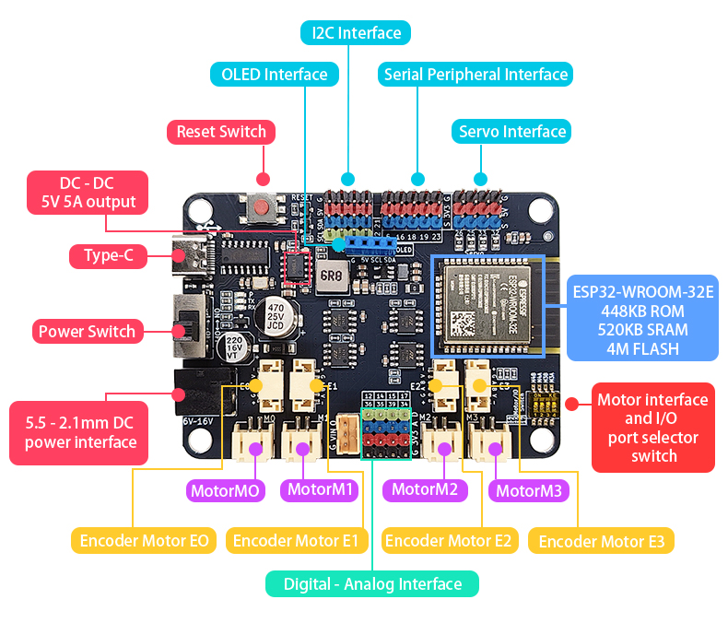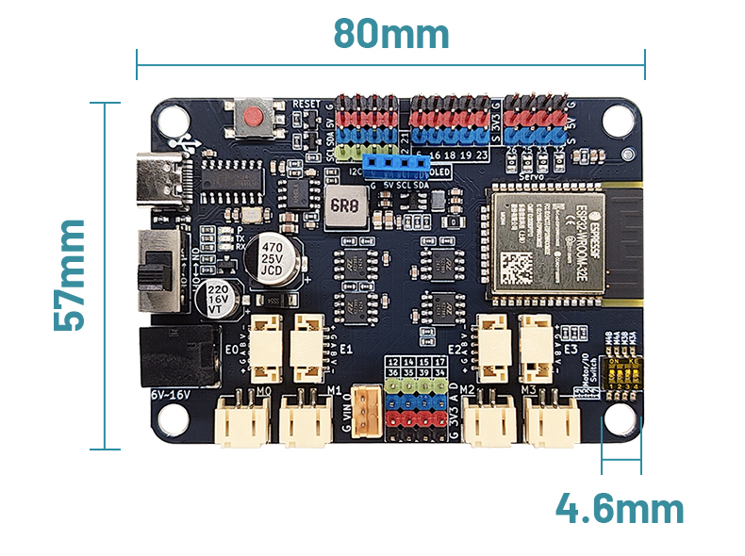Four encoder motor ports (E0, E1, E2, E3); four DC motor ports (M0, M1, M2, M3), which share the same ports with the encoder motors. The maximum current can reach 3A.

* Among them, E0 (A: 18, B: 19, +: 27, -: 13), E1 (A: 5, B: 23, +: 4, -: 2), E2 (A: 35, B: 36, +: 17, -: 12), E3 (A: 34, B: 39, +: 15, -: 14).
* Five I2C pin headers and one SPI pin header.
* Four servo interfaces (25, 26, 32, 33).
* Thirteen IO pins (5, 12, 14, 15, 16, 17, 18, 19, 23, 34, 35, 36, 39).
* Input voltage: 6 - 16V.
* Product dimensions: 80mm × 57mm; PCB thickness: 1.6mm; Net weight: 35g.
* Diameter of M4 locating holes: 4.6mm, compatible with Lego.
* Software support: Mixly, Arduino IDE, Python.

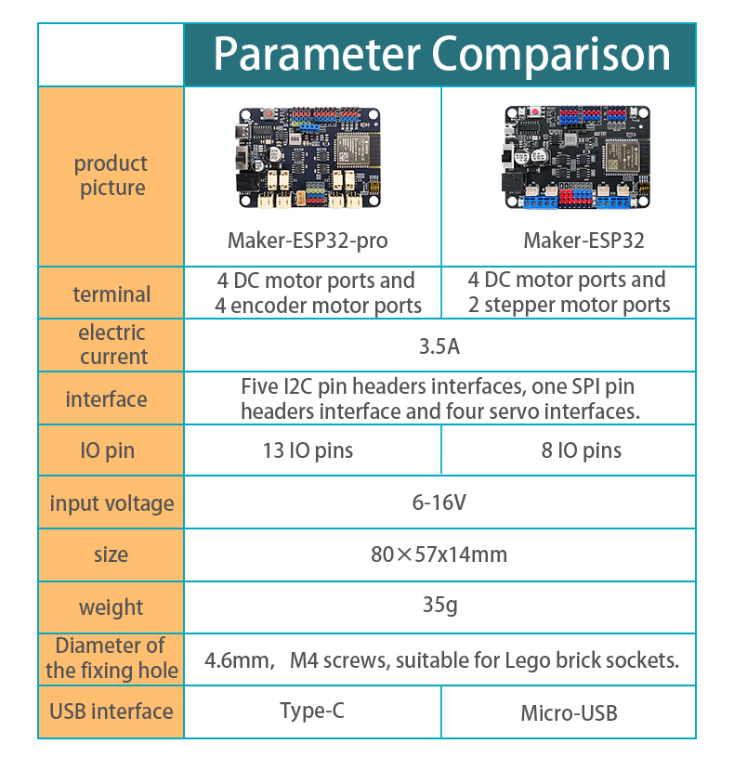 **Experimental scenario**

Compatible with PS3 Gamepad