Unidarts N1 chip manual

Note: Unidarts N1 chip only works for the Nexus board.
!!! PLS USE 5V POWER ONLY !!!!
CHIP INSTALLATION
Please follow the YouTube video to fix your chip:
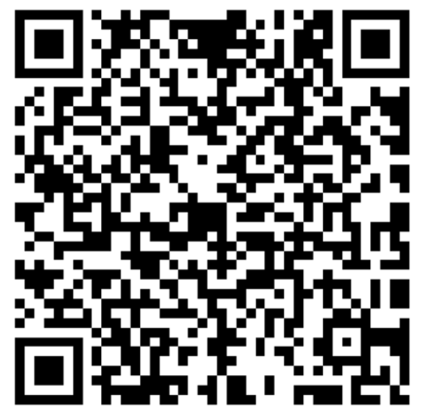
APP SWITCHING
The chip boots into BT mode by default. You can always switch to the APP you would like to use by press the inner single segments and hold the player change button at the same time. (for example: player change button + inner single 2 = DL HOME)
You will get 3 quick beeps when the switching been triggered.
Supported APP list:
- GRANBOARD
- DARTSLIVE HOME
- VDarts GAME
- SDBPLAY2
- DARTSBEAT HOME
- Guz World
- Unicorn Score Buddy
- DR-DARTS
- ADARTS
You can also switch to bypass mode (where you can use the Nexus system) by holding the button for 6 seconds.
OTA UPDATE (for bug fix and feature adding)
- Prepare a WIFI hot-spot named unidarts with password 12345678
- Hold the player change button and press the inner bull to trigger the OTA UPDATE process.
- You will get consistently beeps during the OTA UPDATE process, and it ends with a long beep followed by 2 short beeps.
- Then it boots into system with 1 beep again. You can now switch to other apps if you want.

