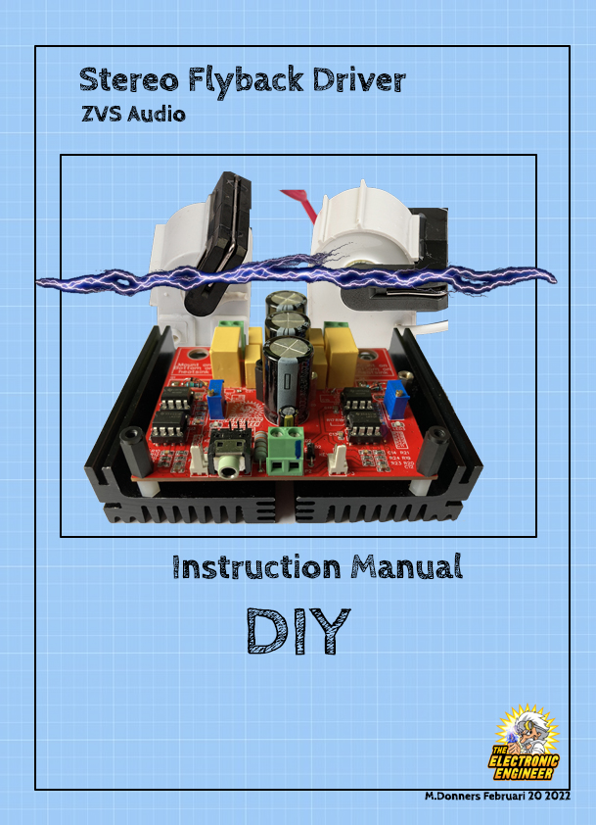
Disclaimer:
I, Mark Donners, The Electronics Engineer, may or may not endorse various Do-It-Yourself (DIY) projects and all DIY projects are purely “at your own risk”. As with any DIY project, unfamiliarity with the tools and process can be dangerous. Posts should be construed as theoretical advice only.
If you are at all uncomfortable or inexperienced working on these projects (especially but not limited to electronics and mechanical), please reconsider doing the job yourself. It is very possible on any DIY project to damage belongings or void your property insurance, create a hazardous condition, or harm or even kill yourself or others.
I will not be held responsible for any injury due to the misuse or misunderstanding of any DIY project.
By using the information provided by me, (Website,Youtube, facebook and other social media), you agree to indemnify me, affiliates, subsidiaries and their related companies for any and all claims, damages, losses and causes of action arising out of your breach or alleged breach of this agreement(disclaimer).
The materials on this site are distributed “as is” and appear on the site without express or implied warranties of any kind, except those required by the relevant legislation. In particular I make no warranty as to the accuracy, quality, completeness or applicability of the information provided.
The information provided is for entertainment and promotional purposes only. You may not rely on any information and opinions expressed in it for any other purpose.

Disclaimer short version:
This is a DIY project, use any provided information and/or materials at your own risk! I am not responsible for what you do with it!
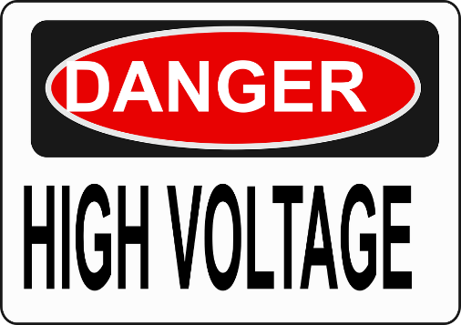

Make sure that you know what you are doing! High voltage can kill!

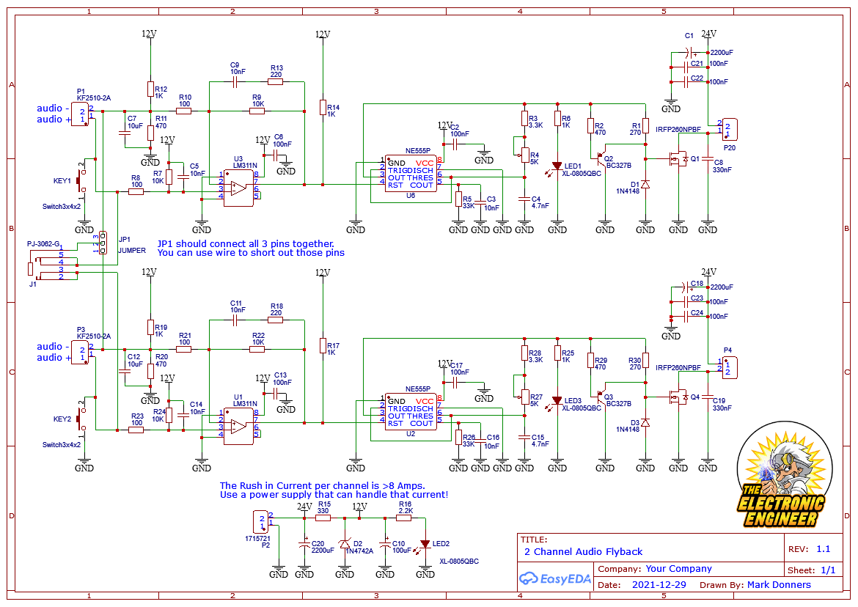

You can get the PCB for this design here:
www.tindie.com
The pcb is available “as is” or with pre-assembled components. If you buy the pcb with pre-assembled components, Heatsinks, U1, U2, U3, U6, Q1, Q4, D1 and D3 are NOT included!
The assembled PCB will look like this:
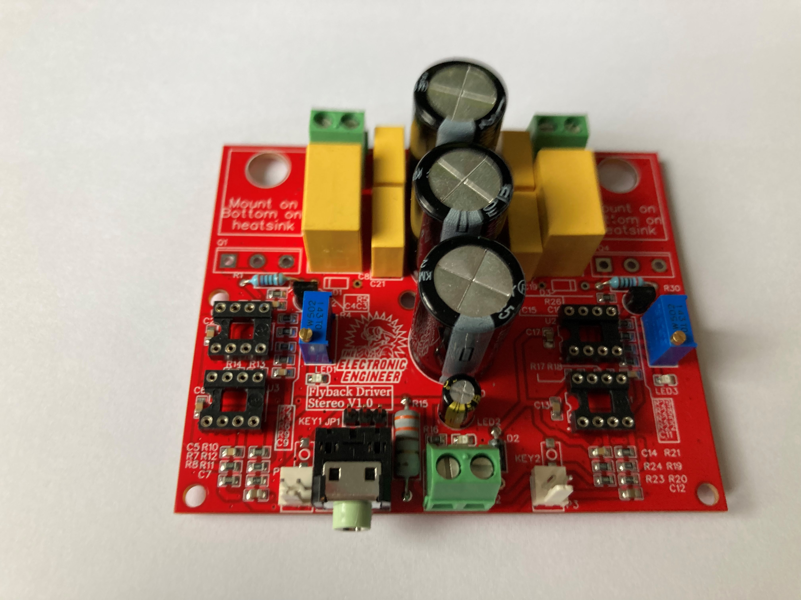

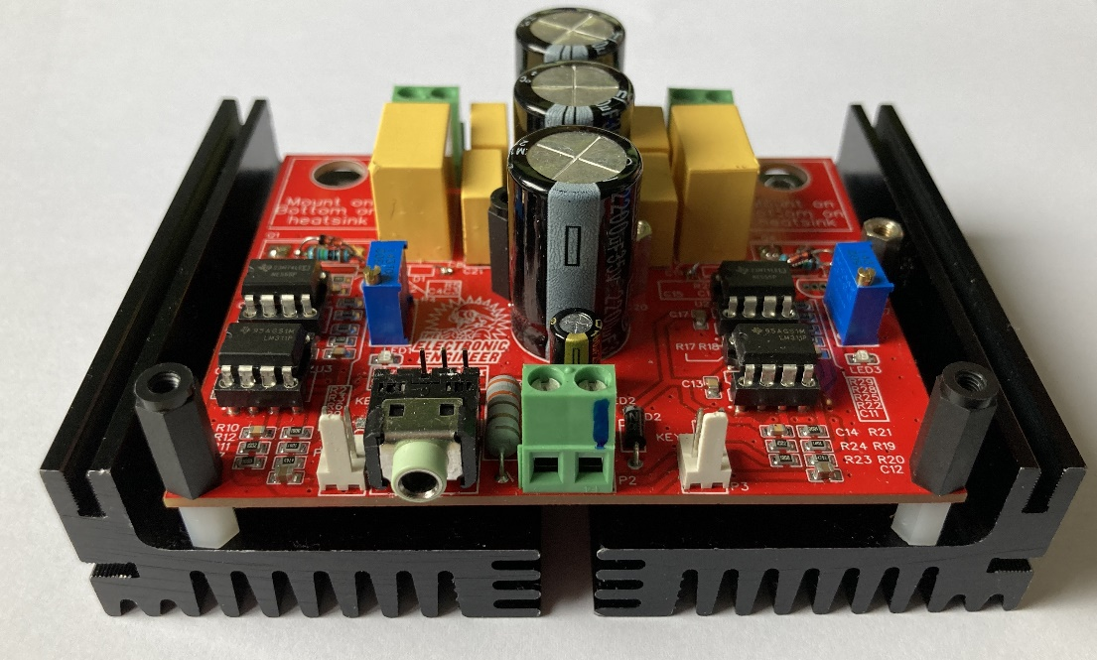
You will have to add: Heatsinks, U1, U2, U3, U6, Q1, Q4, D1 and D3. After you do, it will look like something like this:

Here is the full component list ( BOM ) The components with Yellow highlight, are the only once’s you need to add if you buy a pre-assembled PCB
Designator | Name | Footprint | Quantity | Manufacturer Part | Manufacturer | Supplier | Supplier Part
C21,C22,C23,C24 | 100nF | CAP-TH | 4 | MKP104K275A17 | Jimson | LCSC | C434192
J1 | PJ-3062-G | AUDIO-TH | 1 | PJ-3062-G | XKB Enterprise | LCSC | C381120
P1,P3 | KF2510-2A | CONN-TH | 2 | KF2510-2A | BOOMELE | LCSC | C27543
C1,C18,C20 | 2200uF | CAP-TH | 3 | 2200uF 35V 16X25 | ValuePro | LCSC | C2763
C11,C14,C16,  C3,C5,C9 | 10nF | C0805 | 6 | CL21B103KBANNNC | SAMSUNG | LCSC | C1710
C12,C7 | 10uF | C0805 | 2 | CL21A106KAYNNNE | SAMSUNG | LCSC | C15850
C13,C17,C2,C6 | 100nF | C0805 | 4 | CC0805KRX7R9BB104 | YAGEO | LCSC | C49678
C15,C4 | 4.7nF | C0805 | 2 | 0805B472K500NT | FH | LCSC | C1744
C8,C19 | 330nF | CAP-TH | 2 | MKP334K310A01 | Jimson | LCSC | C434224
C10 | 100uF | CAP-TH | 1 | 100uF 25V | ValuePro | LCSC | C44601
D1,D3 | 1N4148 | DO-35 | 2 | 1N4148 | FMS | LCSC | C163750
JP1 | JUMPER | JUMPER_1X3/2.54 | 1
KEY1,KEY2 | Switch3x4x2 | SW-SMD | 2 | Switch3x4x2 | ReliaPro | LCSC | C26638
LED1,LED2,LED3 | XL-0805QBC | LED0805-RD | 3 | XL-0805QBC | KENTO | LCSC | C2293
P2,P4,P20 | 1715721 | CONN-TH_P5.08 | 3 | 1715721 | Phoenix Contact | LCSC | C480516
Q1,Q4 | IRFP260NPBF | TO-247AC | 2 | IRFP260NPBF | IR | LCSC | C2678
Q2,Q3 | BC327B | TO-92-3 | 2 | BC327B | CJ | LCSC | C16826
R1,R30 | 270 | RES-TH | 2 | MFR0W4F2700A50 | UniOhm | LCSC | C58658
R16 | 2.2K | R0805 | 1 | 0805W8F2201T5E | UniOhm | LCSC | C17520
R17,R19,R25,  R6,R12,R14 | 1K | R0805 | 6 | 0805W8F1001T5E | UniOhm | LCSC | C17513
R18,R13 | 220 | R0805 | 2 | 0805W8F2200T5E | UniOhm | LCSC | C17557
R20,R2,R29,R11 | 470 | R0805 | 4 | 0805W8F4700T5E | UniOhm | LCSC | C17710
R21,R23,R8,R10 | 100 | R0805 | 4 | 0805W8F1000T5E | UniOhm | LCSC | C17408
R22,R24,R7,R9 | 10K | R0805 | 4 | 0805W8F1002T5E | UniOhm | LCSC | C17414
R26,R5 | 33K | R0805 | 2 | 0805W8F3302T5E | UniOhm | LCSC | C17633
R28,R3 | 3.3K | R0805 | 2 | 0805W8F3301T5E | UniOhm | LCSC | C26010
R4,R27 | 5K | TH_3296W | 2 | 3296W-1-502LF | BOURNS | LCSC | C60620
R15 | 330 | RES-TH | 1 | EWWR0001J330RT9 | ResistorToday | LCSC | C348842
U1,U3 | LM311N | DIP-8 | 2 | LM311N | HGSEMI | LCSC | C434572
U6,U2 | NE555P | DIP-8 | 2 | NE555P | TI | LCSC | C46749
D2 | 1N4742A | DO-41 | 1 | 1N4742A | PANJIT Int. | LCSC | C304040
Heatsinks of  your choice |  |  | 2

If you are assembling this PCB yourself, make sure you start with all the small components. Also Take not of how to solder Q1 and Q4. I soldered them at the bottom of the PCb but I made sure that the connection of the pins is still correct.
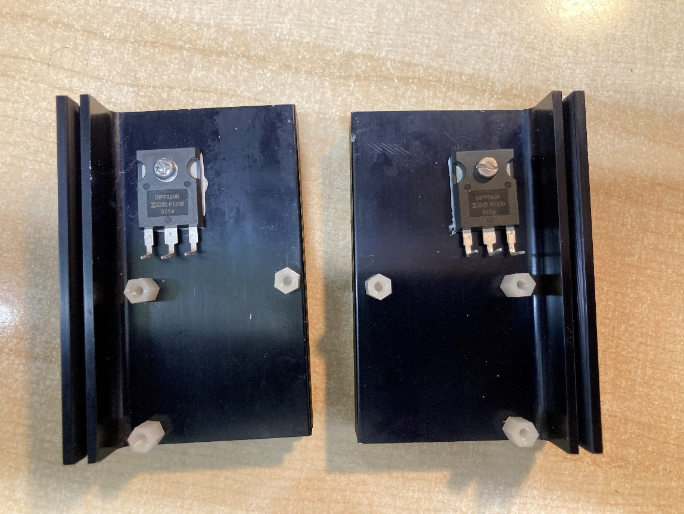

Next, I place the PCb on top and solder the pins of the mosfets. Take not how I used isolated spacers! Also, make sure that the heatsinks don’t touch! The left and right channel have to stay separated. If you are using 1 heatsink and not two, you will have to isolate the mosfet from the heatsink using thermal pads.

Powersupply
The powersupply of this unit should be 24V / 16A. That 16A current might seem a lot but it is needed for the inrush current everytime a spark starts up. I actually used two fully charged Lead-Acid rechargeable batteries in series that I harvest from an absolute UPS unit.

Audio
This unit works best with square wave audio. I actually transformed a midi file using FL Studio. I hooked up a VST square wave generator plugin to the channel I want to use and saved it as MP3. So in the end I got a two channel square wave audio in MP3 format.

Flyback transformer
I used two flyback transformers that I bought at Aliexpress. Look for BCS25T1010A if sumular.
I wraps 8 turns of wire ( 1mm² core) on the ferrite core to be used as a primary inductor.
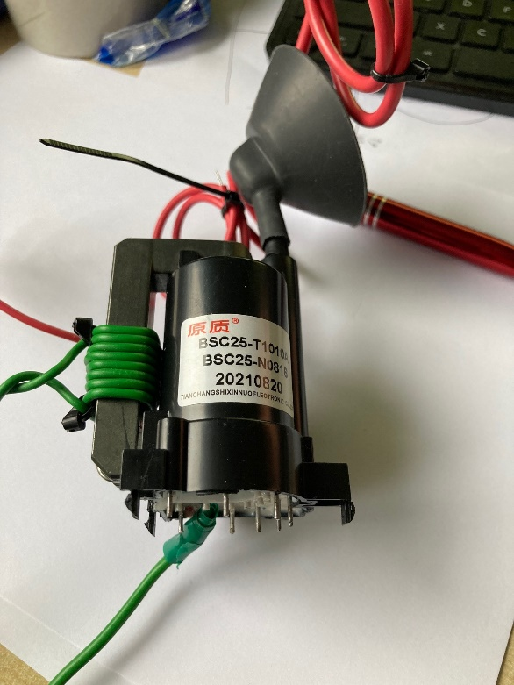

I soldered the ground wire, ( where the spark from the high voltage output will jump to) and added some extra isolation. It doesn’t look pretty, I know, but it did what it needed to do.
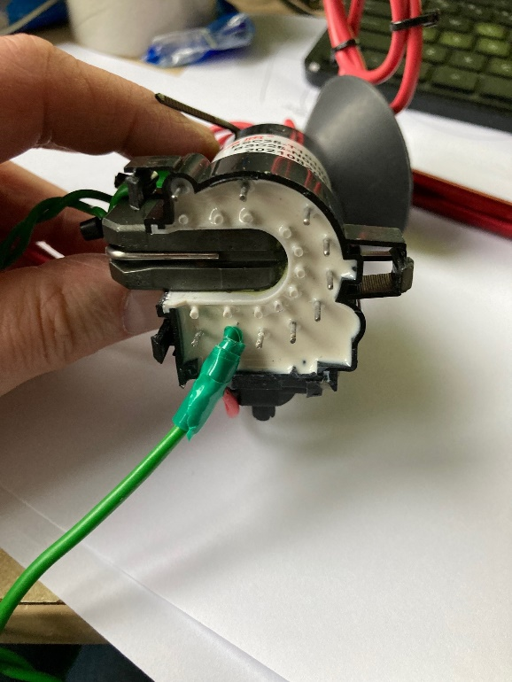

Remember: While experimenting: Stay Safe!

