GGreg20_V3 Ionizing Radiation Detector

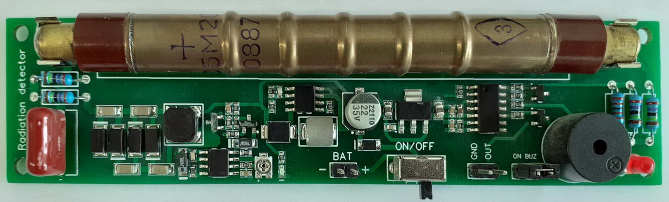
Description
The ionizing radiation detector GGreg20_V3 - a ready-to-use redesigned new generation device with Geiger tube SBM-20 and pulse counting output to the controller. Designed by IoT-devices in Kyiv, Ukraine.

Purpose
Radioactive particles detector - an electronic sensor module for building a personal ionizing radiation level counter. For this purpose, the detector includes an impulse counting output to a host controller. Arduino, Adafruit, ESP8266, ESP32, and others can be used as a host controller.

The radiation level is displayed by light and sound signals. Sounds can be muted by the user (jumper J1 - buzzer on/off).

GGreg20_V3 - a cheap and useful device for checking the "purity" of:
- mushrooms,
- berries,
- vegetables,
- firewood, etc.

This module is useful to build smart measurement devices for ionizing radiation power sensing in handheld / pocket design style or in stationary mode both for indoor or outdoor operation.
The only thing you need to start measuring the power of ionizing radiation with any GGreg20 module is any microcontroller that can count the number of pulses per unit of time on GPIO.

Specifications
- Module dimensions - 30 x 126 x 12 mm. Weight 30 g.
- Power supply:
  - from a rechargeable battery or a battery:
    - 1 cell Li (3.7V) battery
    - 2 cell Ni (2.4V) battery
    - 3 cell (4.5V) battery
connecting to port "Bat";
  - from a 5 Volt charger.
- Power supply of the SBM-20 tube - built-in adjustable high voltage DC-DC converter. The target 400V voltage level is regulated by a potentiometer. The module is sold with fine-tuned parameters and ready for use.
- Consumption current - 18 mA at 5V or 30 mA at 3.7V via LiIon.
- GGreg20_v3 is compatible with logic signal levels (3V3 ACTIVE-LOW: 3 to 3.3V in HIGH state and about 0.7V in LOW state) of ESP8266 / ESP32, and will work even with a 5V logic input.

Dimensions and Pin assignments

GGreg20_V3 module pin assignments are as follows:
- BAT - Power supply input 2.2V - 5.5 V;
- ON/OFF - Main switch on/off;
- OUT - Pulse output, active-low;
- BUZ - Buzzer enable jumper.

Sizes and dimensions of GGreg20_V3 module are as follows:
- X: 126 mm;
- Y: 30 mm;
- Z: 12 mm.
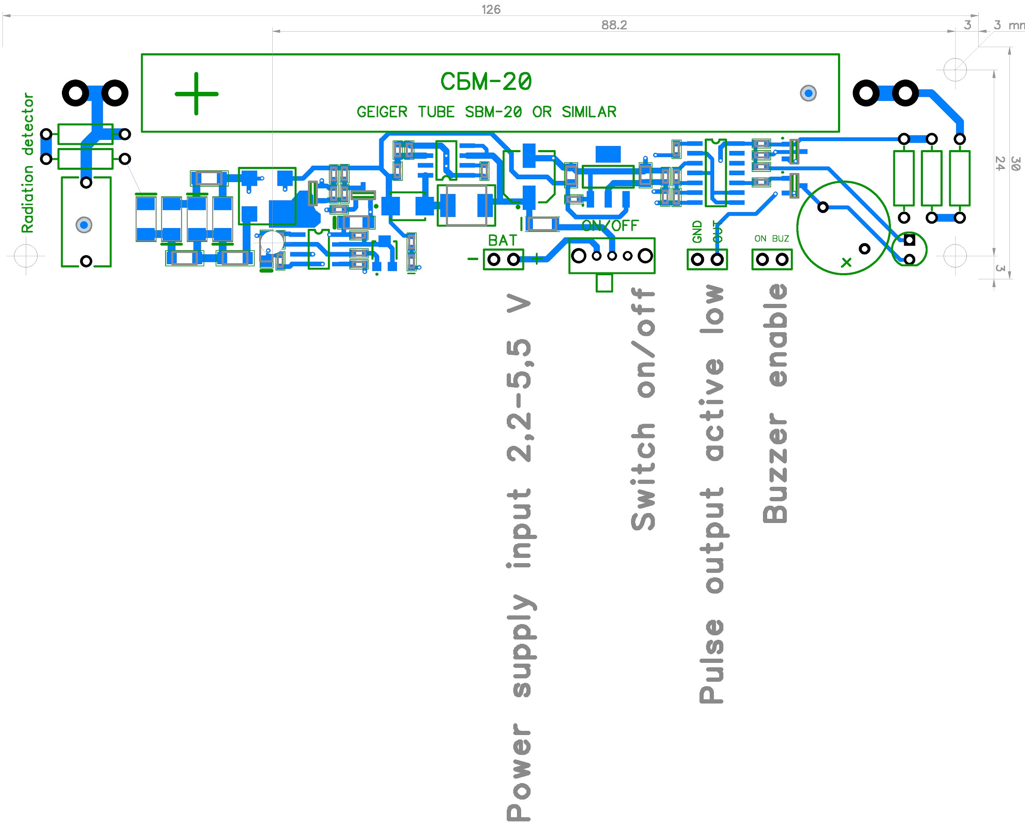

Differences and compatibility with the previous versions of GGreg20

Names of characteristics | GGreg20_V3 (NEW) | GGreg20_V1 | Improvement status
Design | monomodular | two-module | Improved
Calculation formula | No change
The design and size compatibility | Same, except placing the power switch |  | mostly unchanged
Stability of detection results during battery discharge | In the range of 2.4 - 5.5 volts (see ^{note 2 and note 3}) | Only at a supply voltage of 5 volts (uUSB input) | Improved
Measurement accuracy | 20% | 20% | no change
Power supply voltage range | 2.2 - 5.5 volts (see ^{note 2 and note 3}) | 3.7 - 5.5 volts | Improved
Current consumption | near 30 мА | near 30 мА | no change
Autonomous power supply | 1 cell Li (3.7V) or 2 cell Ni (2.4V) or battery 3V or AC / DC adapter 2.4 - 5.5 V (see ^{note 2 and note 3}) | 1 cell Li (3,7V) or 3 cell Ni (3,6V) or 3 cell battery (4,5V) or AC/DC (5V) adapter | Improved
User interfaces | LED, buzzer, Output connector | LED, buzzer, Output connector | no change
The complexity of integration in devices | Two connectors and one jumper (total 6 pin) | Three connectors and a jumper (11 pin in total) | Simplified
Protection against connection errors | Key connectors used and Schottky diode installed (see ^{note 2 and note 3}) | Not provided | Improved

^{Note 1} GGreg20_V2 module version was not included in comparison because it was designed for other design solutions (and it does not provide space for SBM-20 tube on plate placement).

^{Note 2} By default, the module board has a protection diode against false reversal when connecting the battery. This narrows the voltage range of the input power supply: 3 - 5.5 volts.

^{Note 3} If you want to power the GGreg20_V3 from a 2.4 volt source, you need to short the Schottky diode shown in the figure below with a wire or replace it with a 0 ohm resistor. Note, however, that this correction will disable the module's power supply polarity reverse protection.

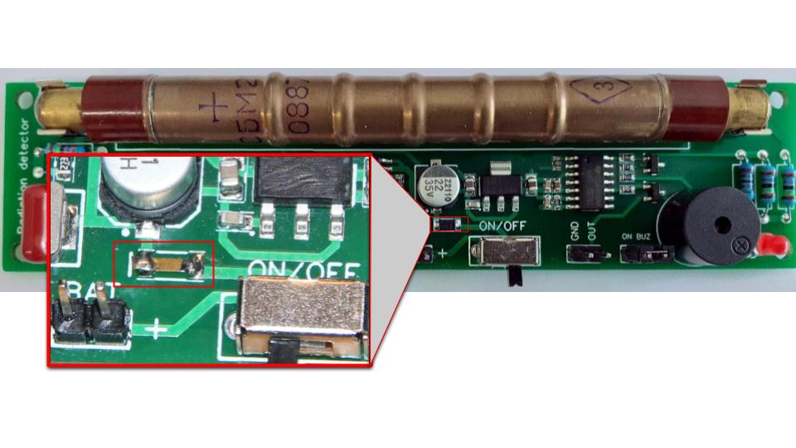
Fig. GGreg20_V3 Reverse Polarity Protection Diode Manual Replacement Example

Switching-on and measurements

! | This module is ready for use. The GGreg20_V3 modules are adjusted, configured and tested for compliance with the declared technical data before being shipped. Any adjustments or settings made by the customer may damage the module or introduce technical inconsistencies.

Connect the power input from the selected power source.

Turn on the power supply and in 10-15 seconds, you will hear the sound and see light signals when active particles enter the tube.

With a normal background level of radiation, the tube registers and generates 20-30 pulses per minute. The number of pulses can fluctuate depending on the weather or cosmic radiation.
Consider the average number of signals per minute.

If you receive more than 60 signals per minute, be careful. Your detector has "felt" the effects of ionizing radiation emissions from the ambient environment or food, mushrooms, or wood, etc.

In short, the formula is simple: you need to accumulate the number of ingoing GPIO pulses per minute and then multiply by a factor. Like this:

microsieverts per hour = (impulses per minute) * 0.0092

where 0.0092 coefficient is obtained from the manufacturer’s documentation on the tube.

Tubes may vary (+-20%), so we recommend using a conversion factor from 0.0054 to 0.0092 and calibrate your calculations against a trusted (certified) device.

Product kit sets:

GGreg20_V3 basic

- GGreg20_V3 module --- 1 pc.
- SBM-20 tube --- 1 pc.

Connectors (installed) and cables

- GGreg20_V3 module --- 1 pc.

- SBM-20 tube --- 1 pc.

- Connectors JST XH 2P male straight --- 2 pcs.
installed on the module board;

- Pulse output cable 15 cm with connectors --- 1 pc:
  - JST XH 2P female on one side and
  - Dupont 2x1P female on the other side

- Power supply input cable 15 cm with JST XH 2P female connector on one side --- 1 pc.

References

Manufacturer site | https://iot-devices.com.ua
Shop on Tindie for international orders | https://www.tindie.com/stores/iotdev/
Shop for local orders within Ukraine | https://iot-devices.com.ua/shop/
Facebook page | https://www.facebook.com/IoT-devices-114746816966582
Twitter | https://twitter.com/iotdevicescomua
YouTube | https://www.youtube.com/channel/UCHpPOVVlbbdtYtvLUDt1NZw
Email | info@iot-devices.com.ua

Document update history
2021/05/13 - initial document.
2021/11/20 - minor fixes and additions on reverse protection diode.

Manufacturer message
Dear Reader! Thank you for your interest in our products. We hope that you enjoy this device.
IoT-devices was born thanks to the support of our customers and thanks to our experience and love for Electronics.
Шановний Читач! Дякуємо що цікавитеся нашими продуктами. Сподіваємося, що вам сподобається і цей наш пристрій. IoT-devices народився дякуючи підтримці наших Клієнтів та завдяки нашому досвіду і закоханості в Електроніку.

Designed and made by IoT-devices with freedom & wisdom in Ukraine - 2021. All rights reserved.
Розроблено дизайн та виготовлено компанією IoT-devices зі свободою і мудрістю в Україні у 2021 році. Всі права застережено.

