SA818 high-integrated Embedded walkie talkie module
Descriptions:

SA818 is a low cost but high performance integrated walkie talkie module.With built-in high performance microcontroller, narrow band rf transceiver and standard UART interface it can be easily used and succeed all the walkie talkie function with good quality voice and long distance transmission. Users only need to connect external audio amplifiers, microphone or speaker with this module ,then it can work as a small walkie talkie with 1W output. In open area, it can easily achieve 3.5-5Km communication. Simplified interface and ultra small size make this module a wide range of applications, also can conveniently embed into various handheld devices,to improve the comprehensive performance of end products.
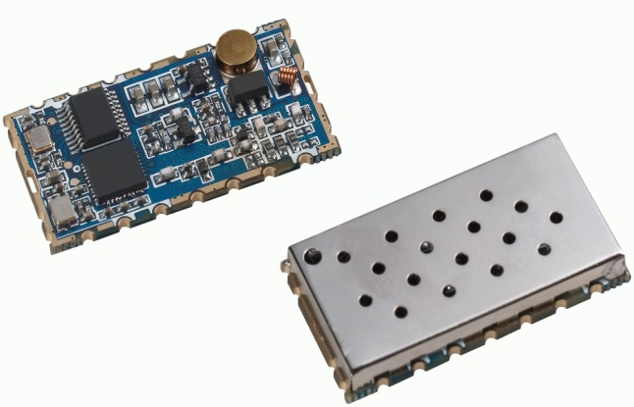

Features:
  - Frequency: 400 ~ 480 MHz (UHF)
  - 134~174MHZ (VHF)
  - Tx and Rx frequency, Tx and Rx CTCSS,CDCSS can be set alone.
  - Band width 12.5/25KHz
  - Output power up to 1 w
  - Transmission distance up to 3.5 to 5 km in Open area
  - sensitivity: - 124 DBM
  - small size
  - Built-in EEPROM, data kept unchanged even powered off
  - 38 CTCSS
  - 166 CDCSS
  - 8 level squelch
  - 8 adjustable volume
  - high/ low power is optional (500 mw)-1w
  - wide range of working voltage 3.3 to 5.5 V
  - 1 ppm KDS TCXO crystal,

Application:
  - small walkie talkie
  - Invisible intercom system
  - Sport products
  - building community security system
  - audio surveillance system

Specification:
Parameter | Test condition | Min | Typ | Max | Unit
Power supply |  | 3.3 | 4.2 | 5.5 | V
Working Temperature range |  | -30 | 25 | 85 | ℃
Current consumption
Sleep current | @PD = 0V |  | ≤1 |  | uA
RX current |  |  | 60 |  | mA
TX current（High power） |  |  | 650 | 750 | mA
TX current（low power） |  |  | 450 | 550 | mA
Transmitting RF parameters
Frequency range | UHF | 400 |  | 480 | MHZ
Frequency range | VHF | 134 |  | 174 | MHZ
Out power（High power） | @VCC=4.0V | 28 | 29.5 | 31 | dBm
Out power（low power） |  | 25 | 26.5 | 27 | dBm
Modulation frequency | @1.5Khz/2.5KHZ frequency deviation |  | 10 |  | mV
Audio modulation distortion | @1.5Khz/2.5KHZ frequency deviation |  | 2 | 5 | %
Signal to Noise Ratio | @1.5Khz/2.5KHZ frequency deviation | 38 | 40 | 45 | dB
adjacent-channel power | @12.5K offset |  | -60dBc |  | dBm
CTCSS Modulation frequency |  | 0.35 | 0.5 | 0.75 | KHZ
Receiving RF parameters
Receiving sensitivity |  |  | -124 |  | dBm
Receiving SNR | @1.5KHZ frequency deviation | 45 | 50 |  | dB
Audio output amplitude |  |  | 700 |  | mV
Audio Output impedance |  |  | 200 |  | OHm

Internal block diagram
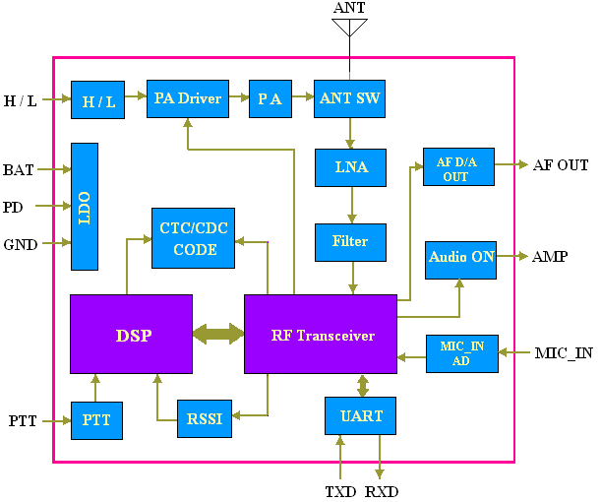
Schematic
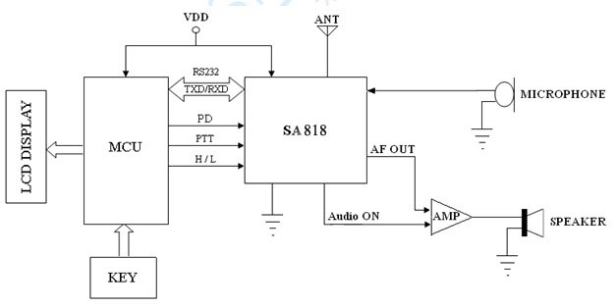
Pinout:
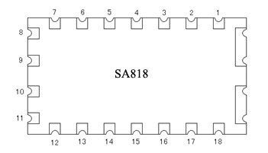

Pin NO. | Pin name | I/O state | Description
1 | Audio ON | O | ,Connected to audio power amplifier. When the module worked, it can control the extra audio amplifier automatically, it will output low level to turn on the amplifier and high level to turn off the amplifier.
2 | NC |  | Not connceted
3 | AF_OUT |  | Audio output
4 | NC |  | Not connceted
5 | PTT | I | Module Input, Transmitting/receiving control feet, "0" force the module enter TX state; and "1" to Rx state
6 | PD | I | Module dormancy, "0" or hung up is dormancy; "1" for the normal work
7 | H/L | I | Module Input, high/low output power control; floating or high impeadance force to high output power，low level to low output power. (Please kindly note: this pin can NOT be connected to VDD or high level of cmos output)
8 | VDD |  | Connect power positive
9 | GND |  | Grounding
10 | GND |  | Grounding
11 | NC |  | Not connceted
12 | ANT |  | Antenna input/output (connect 50 ohm antenna)
13,14,15 | NC |  | Not connceted
16 | RXD | I | serial port receiving data
17 | TXD | O | serial port transmitting data
18 | MIC_IN |  | Microphone or line in input

Machine Dimension:
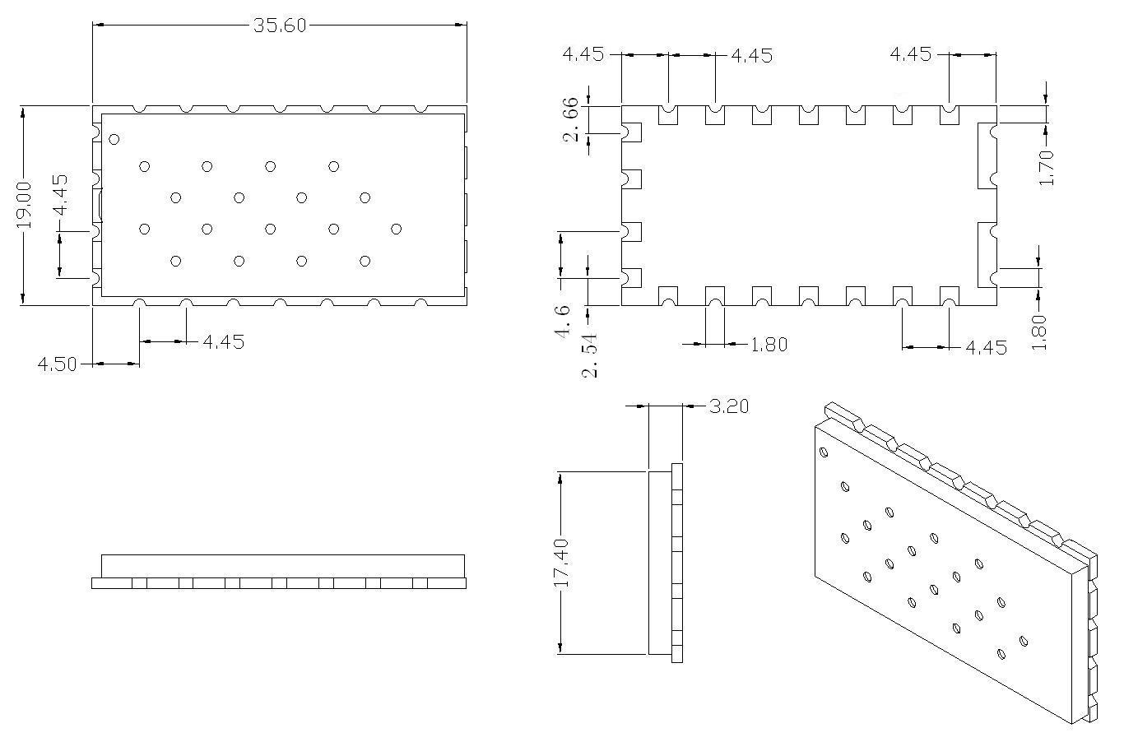
Communication Protocal:
SA818 module provides a standard RS232 Uart interface for users to configurate the parameters in real time. It is very easy to use. For detail protocol, please check SA808 module programming manual.

Appendix:
In additional, we provided DEMO Board for customers to debug program, test function and distance, as shown in the figure below:
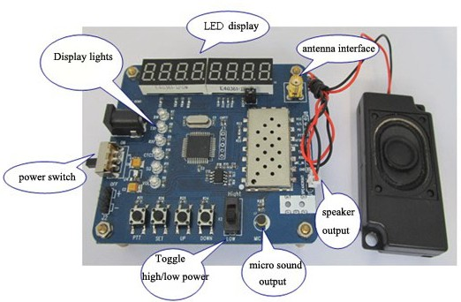
User can set related parameters through the buttons ,as follows
- Tx frequency：400 ~ 480 MHz
- Rx frequency：400 ~ 480 MHz
- Channel Bandwidth：12.5 KHz / 25KHz
- CTCSS：0 ~ 38
- CDCSS: 0--166
- Squelch：0 ~ 8
- Volume：1 ~ 8
- Button Operation：
- [SET ] button
Press to enter setting mode.
- [UP /Down] button
In setting mode, press to increase/decrease the setting item.
- [PTT] button
If Not in setting mode, Press it to talk,( it is in listen state when released)
- [High/Low] slide switch
Switch to high/low output power
Note: with data FLASH inside, all of the parameters set is saved and keep unchanged even power off.

