3D RGB LED Christmas tree KIT
Tindie shop Alexisgm

This kit is very simple and entertaining to build, and everyone can easily do it! Let’s start!

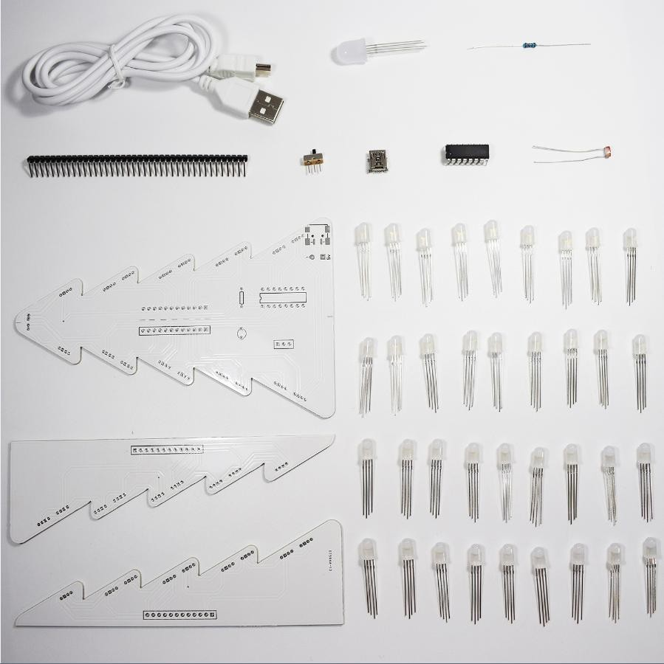
Contents of the kit:

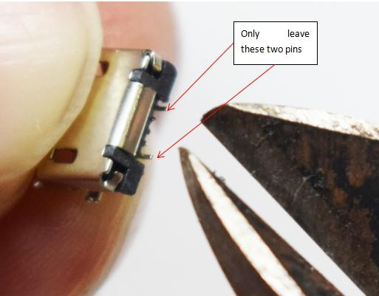
First of all, we need to solder the micro USB socket, we first cut off the middle three pins, leaving only the left and right pin, as shown below:

Solder the micro USB socket as the following image; if you do not want to use the micro USB socket, then you can use the 5V power supply. The polarity is marked on the board. And the connector fits in its position correctly

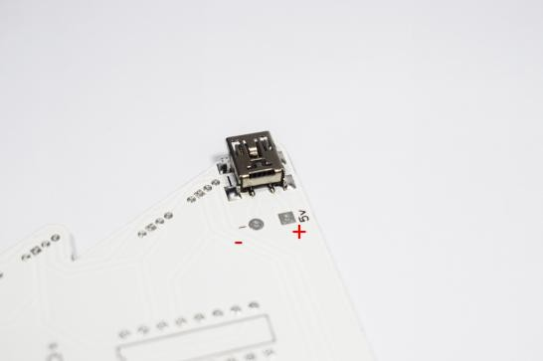

Now we need to solder the IC, resistor, photoresistor and the switch on the right, as shown below. Pay attention to the direction of the chip. It is marked on the board.
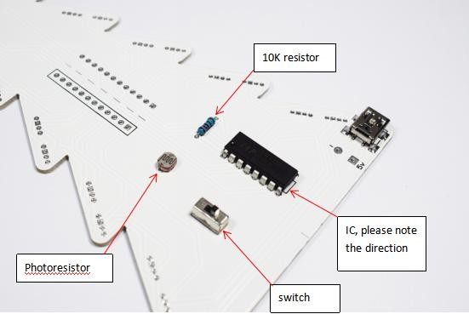

Next, we are going to solder the RGB LEDs, first of all, we need to align the longest LED pin into the square pad, as shown below
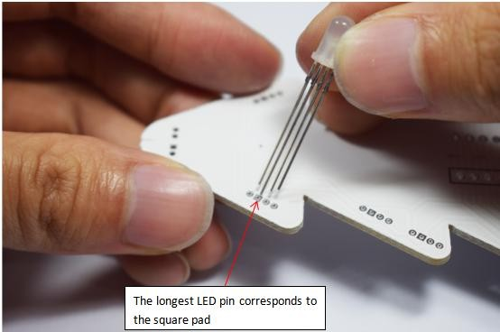

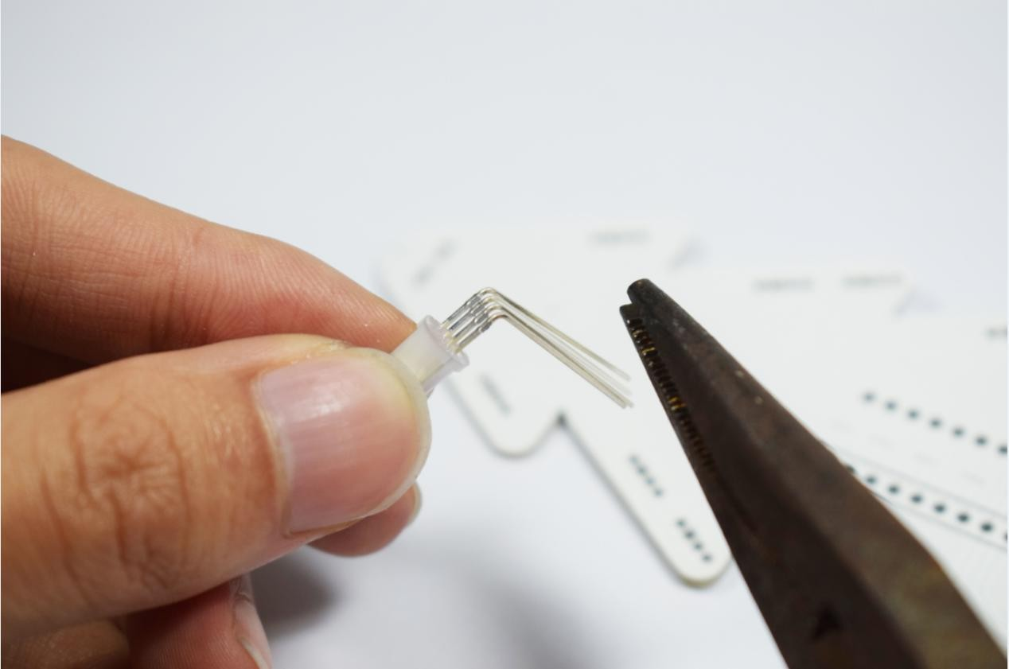
To solder the LEDs, first of all bend the LED pins into a 90 °angle more or less, as shown below:

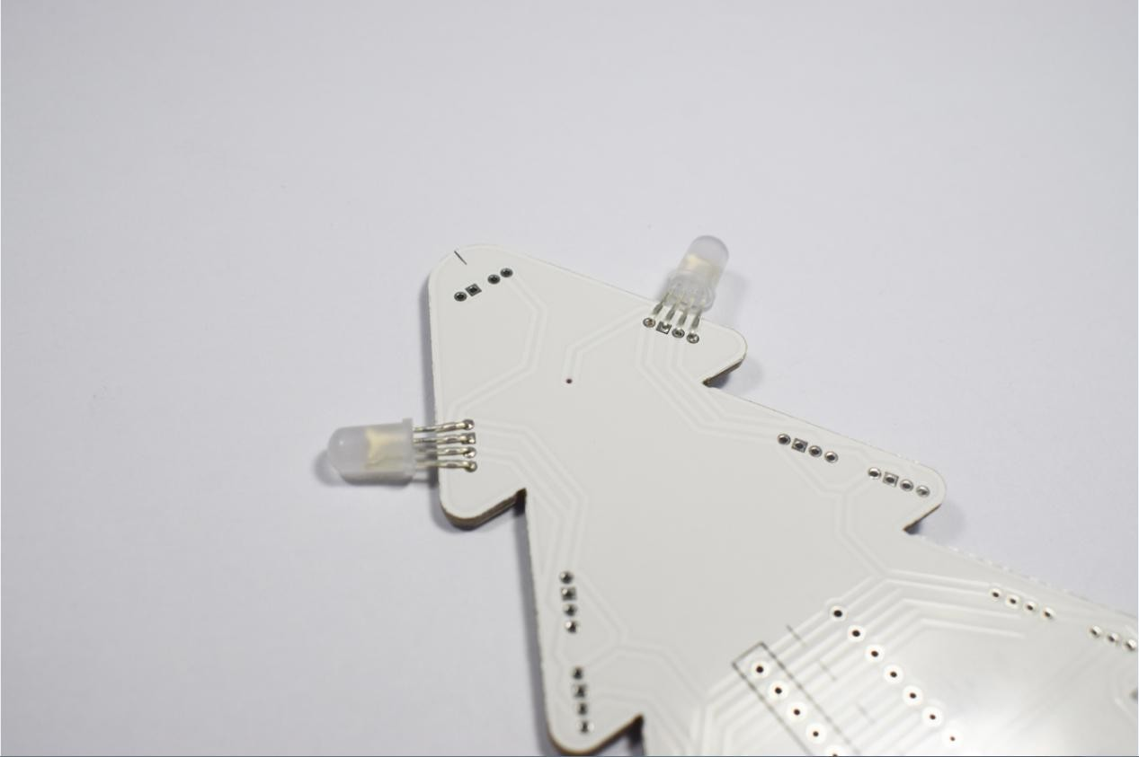

Solder all the LEDs of the first board following the same process.

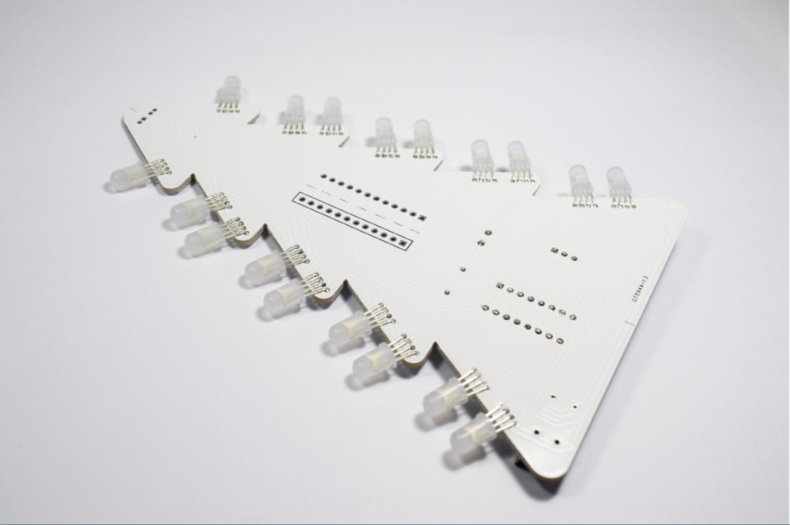
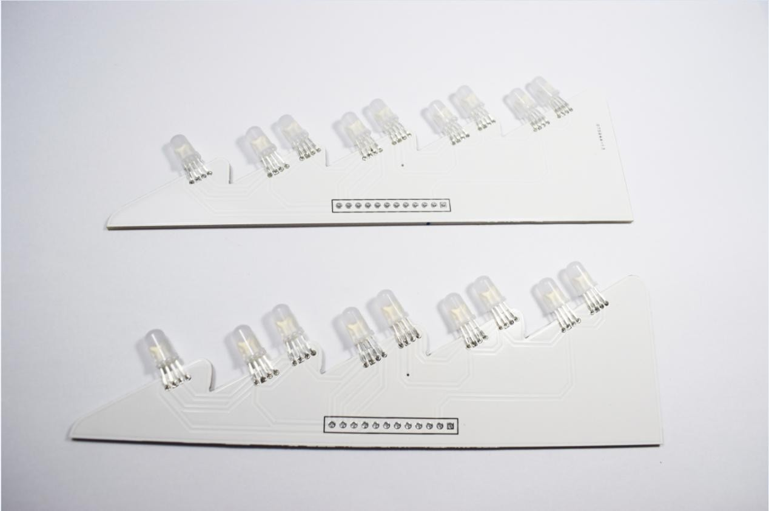
The other two boards have the same process. Solder all the LEDs

Next, we want to use the pin headers to connect the PCBs into a three-dimensional shape tree, first solder the pin to the small circuit board, as shown
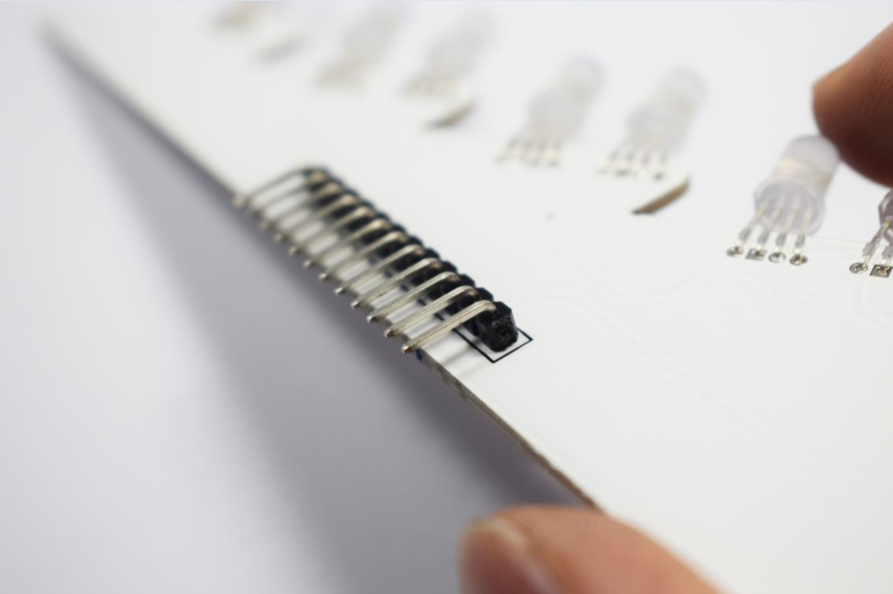

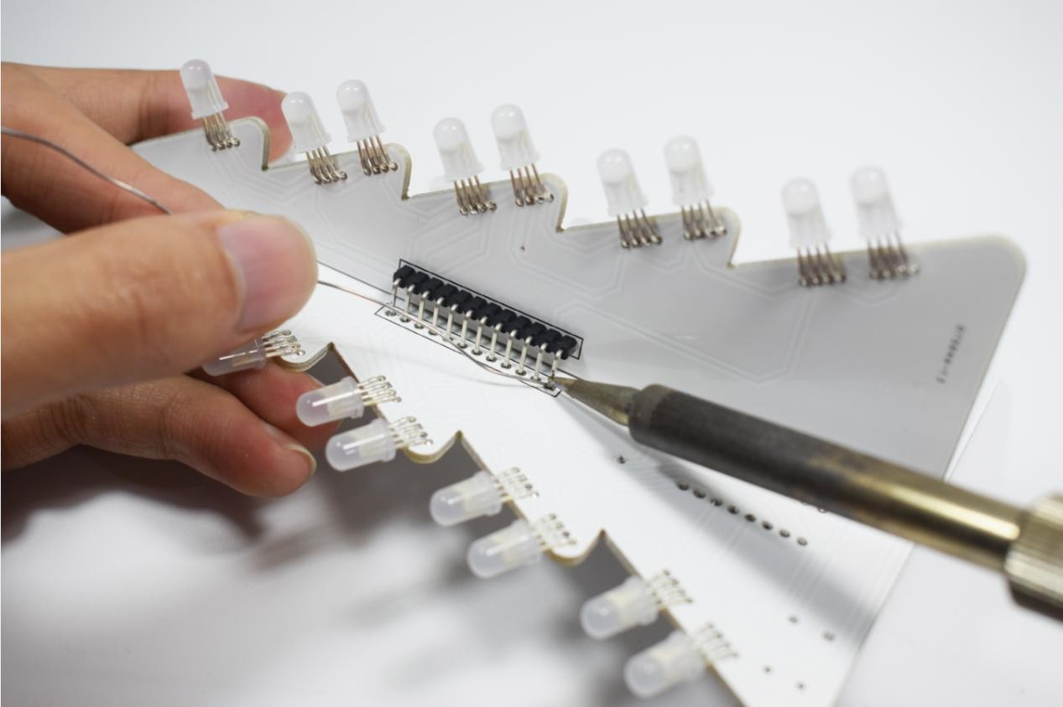

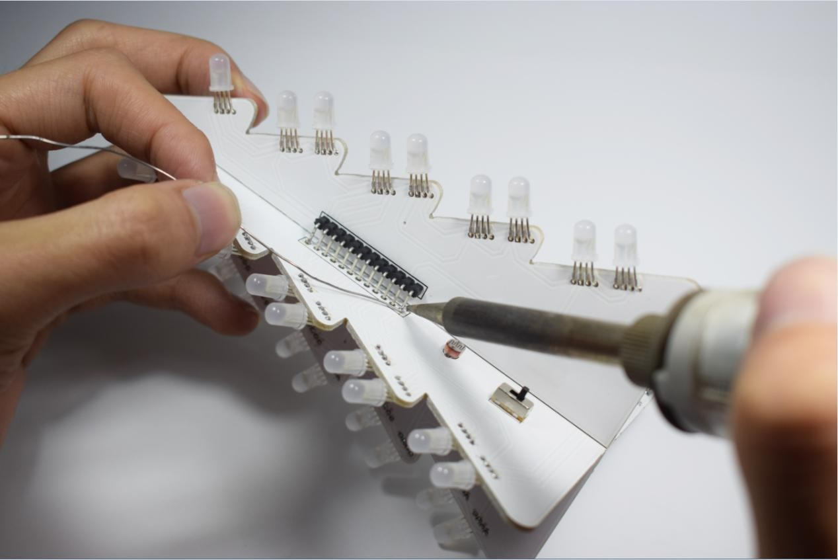
Do the same with the other

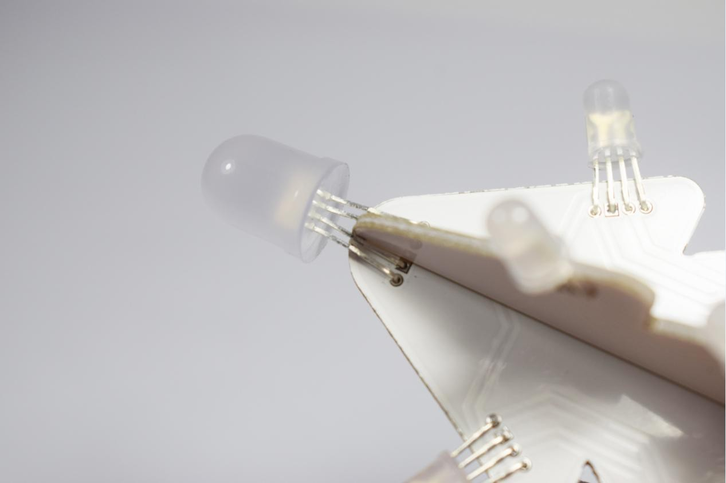
Finally, remember to solder the 10mm RGB LED on the tree tip, pay attention to the long leg corresponding to the square pad. Bend the legs so the other two parts of the board can fit in:

Plug in the USB cable, power bank or 5V output phone charger, this kit has 14 kinds of display effects, turning on and off the switch changes the display effect:
