Instructions for the Use of Model 485 Soil Nitrogen, Phosphorus and Potassium Trinity Transmitter

Chapter 1 Product Introduction

1.1 Product Overview

Soil nitrogen, phosphorus and potassium sensor is suitable for detecting the content of nitrogen, phosphorus and potassium in soil. It can judge the fertility degree of soil by detecting the content of nitrogen, phosphorus and potassium in soil, thus facilitating the systematic evaluation of soil conditions by customers. .

1.2 Scope of Application

It is widely used in paddy field, greenhouse planting, rice, vegetable planting, orchard nursery, flower and soil research, etc.

1.3 Measurement parameters

parameter | Technical Indicators
measuring range | 0-2000 mg/kg
measurement accuracy | 2% F.s
Resolving power | 1 mg/kg (mg/l)
Response time (T90, seconds) | Less than 10
working temperature | From 5 to 45 degrees Celsius
Working humidity | 5 to 95% (relative humidity), no condensation
Guarantee Period | Quality assurance of main engine for 2 years and probe for 1 year
baud rate | 2400/4800/9600
Communication Port | RS485
Power supply | 12V-24V DC

1.4 System Framework Diagram

The sensor can be connected and used separately. Firstly, it is powered by 12V DC power supply. The device can directly connect the PLC with 485 interface, and can connect the single chip through 485 interface chip. The MCU and PLC can be programmed by the Modbus protocol specified later to cooperate with the sensor. At the same time, the computer can be connected by using USB to 485. The sensor configuration tool provided by our company is used to configure and test.

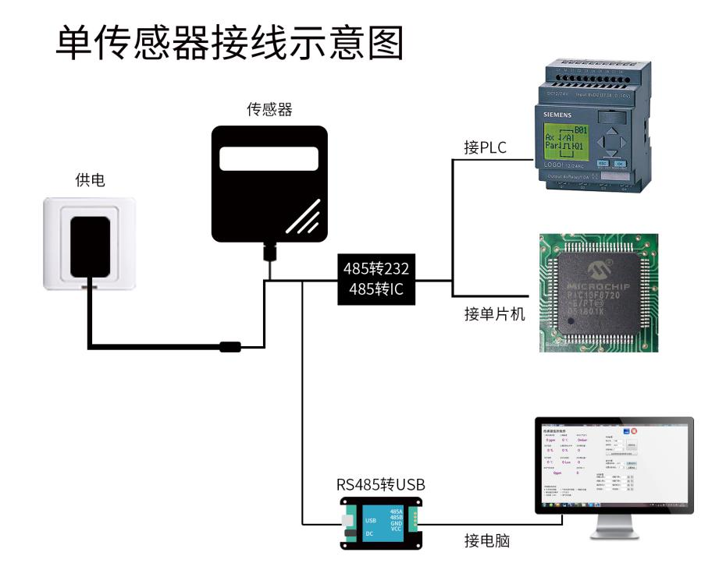

This product can also be used with multiple sensors in a 485 bus. Please observe the "485 bus field wiring code" when combining 485 bus (see appendix). In theory, a bus can have more than 16 485 sensors. If more 485 sensors need to be connected, 485 repeater can be used to expand more 485 devices. The other end can be connected to a PLC with 485 interface, a microcontroller with 485 interface chip, or a computer can be connected by USB to 485, using the transmission provided by our company. Sensor configuration tools are configured and tested.

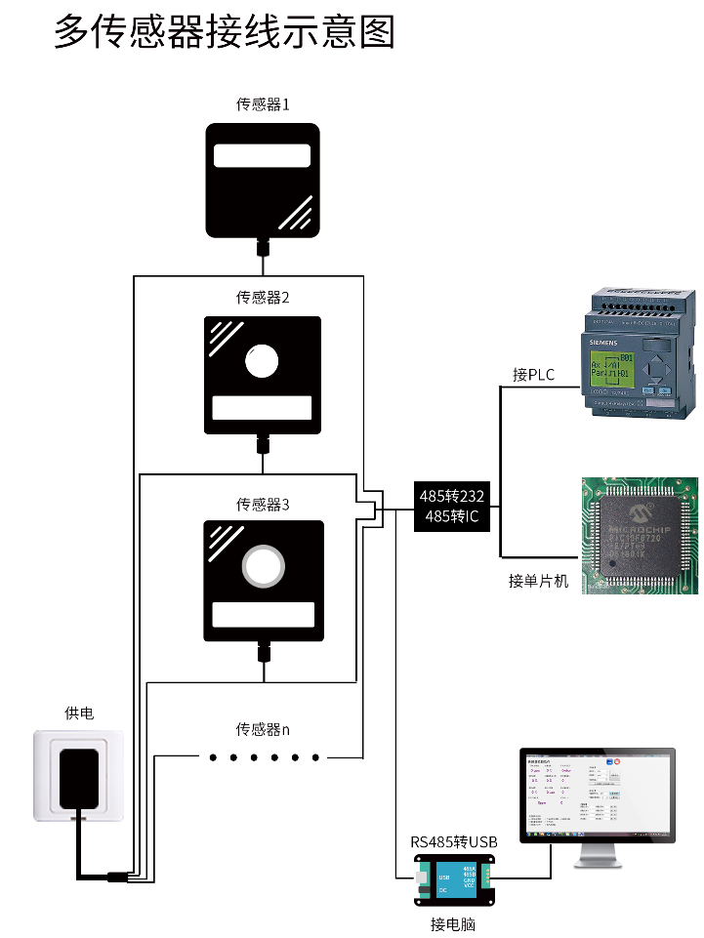
Chapter 2 Hardware Connections
2.1 Pre-installation inspection of equipment

Check the device inventory before installing it:

Name | Number
High Precision Sensor | 1 set
12V Waterproof Power Supply | 1 set
USB to 485 device | 1 set
Warranty Card/Qualification Certificate | 1 set

2.2 Interface Description

The power interface is wide voltage power supply input 12-24V can be. Analog products should pay attention to the positive and negative signal lines, and do not connect the positive and negative current/voltage signal lines.

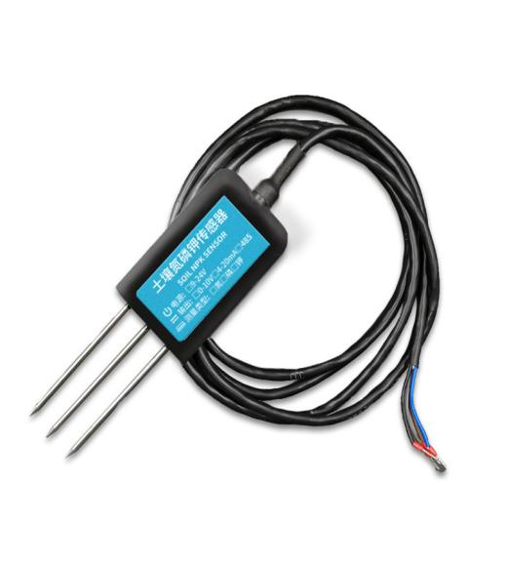

 | Line | Description
Power | Brown | Cathode(12-24VDC)
 | Black | Negative
Communication | Yellow | 485-A
 | Blue | 485-B

Notes: Please be careful not to mistake the wiring sequence, the wrong wiring will lead to equipment burnout.
The factory defaults to provide 0.6m long wire, customers can extend the wire or sequential wiring as needed.
Note that there is no yellow line in the possible sequence in some factory batches. At this time, the gray line replaces the yellow line equally.

2.3 Surface Survey Method

Choose the appropriate measuring location, avoid stones, ensure that the steel needle will not touch hard objects, according to the required measuring depth, throw away the surface soil, maintain the original tightness of the soil below, grasp the sensor vertically inserted into the soil, insertion can not sway left and right, a small range of measurement points suggested that the average value be measured many times.

2.4 Buried Survey Method

When a pit with diameter > 20 cm is excavated vertically, the sensor steel needle is inserted horizontally into the wall of the pit at a given depth, and the pit is landfilled tightly. After stabilizing for a period of time, it can be measured and recorded continuously for several days, months or even longer.

2.5 Notes

1. All steel needles must be inserted into the soil when measuring.

2. Avoid intense sunlight directly irradiating the sensor and causing excessive temperature. Attention should be paid to lightning protection in field use.

3. Don't bend the steel needle violently, pull the sensor lead-out wire forcefully, and don't hit or hit the sensor violently.

4. Sensor protection level IP68 can soak the whole sensor in water.

5. Because of the existence of radio frequency electromagnetic radiation in the air, it is not suitable to be electrified for a long time in the air.

Chapter 3 Installation and Use of Configuration Software

Our company provides a complete set of "sensor monitoring software", which can easily use computers to read sensor parameters, while flexibly modifying the device ID and address of the sensor.

3.1 Sensor Access to Computer

After connecting the sensor to 485 via USB and providing power, you can see the correct COM port in the computer ("My Computer - Attribute - Device Manager - Port").

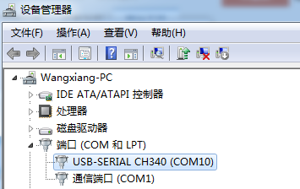

As shown in the figure above, your serial number is COM10 at this time. Please remember this serial number. You need to fill in this serial number in the sensor monitoring software.

If no COM port is found in the device manager, it means that you have not inserted USB to 485 or installed the driver correctly. Please contact the technician for help.

3.2 Application of Sensor Monitoring Software

The configuration interface is shown in the figure. Firstly, the serial number is obtained and the correct serial port is selected according to the method in Chapter 3.1. Then, all devices and baud rates on the current 485 bus can be detected automatically by clicking on the current baud rate and address automatically. Note that there is only one sensor on the 485 bus when using software for automatic acquisition.

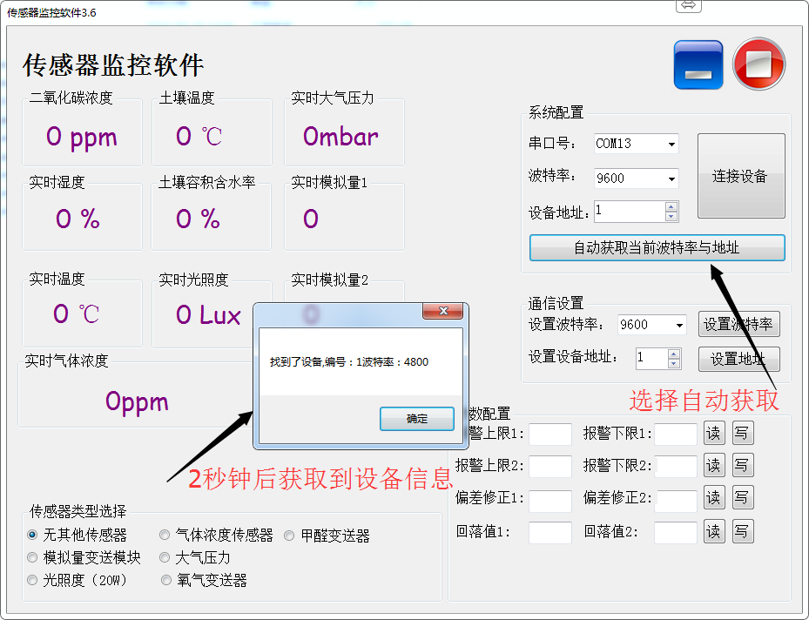

Then the sensor data information can be acquired in real time by clicking on the connection device.

If your equipment is a gas concentration sensor, please select "gas concentration sensor" at the sensor type, formaldehyde sensor choose "formaldehyde transmitter", analog transmitter choose "analog quantity transmitter module", atmospheric pressure sensor choose "atmospheric pressure sensor", and illumination sensor choose "illumination 20". W ", oxygen sensor choose"oxygen transmitter", other sensors choose the default"no other sensor".

3.3 Modify baud rate and device ID

In the case of disconnecting the device, click on the device baud rate and setting address in the communication settings to complete the relevant settings. Please note that after setting, please restart the device, and then "automatically get the current baud rate and address" can find that the address and baud rate have changed to the address and baud rate you need.

If you need to use the Modbus instruction to modify the baud rate and address, you can see the appendix "How to use the Modbus instruction to modify the baud rate and address".

Chapter 4 Communication Protocol

4.1 Basic Communication Parameters
parameter | content
Code | 8-bit binary
Data bits | 8 place
Parity bit | nothing
Stop bit | 1 place
Error Check | CRC (Redundant Cyclic Code)
baud rate | 2400 bps/4800 bps/9600 BPS can be set, default is 9600 BPS

4.2 Data frame format definition
Modbus-RTU protocol is adopted in the following format:
Initial structure >= 4 bytes of time
Address code = 1 byte
Function code = 1 byte
Data area = N bytes
Error Check = 16 Bit CRC Code
End structure >= 4 bytes of time
Address code: The address of the transmitter is unique in the inquiry network (factory default 0x01).
Function code: The instruction function prompt issued by the host computer, this transmitter only uses function code 0x03 (read register data).
Data area: The data area is the specific call area. Note that the high bytes of 16bits data are in front of each other.
CRC Code: Two-byte Check Code
Question frame
Address Code | Function Code | Register Start Address | Register Length | Check Code Low Bit | Check Code High Bit
1byte | 1byte | 2byte | 2byte | 1byte | 1byte

Response frame
Address Code | Function Code | Number of valid bytes Address | Data Zone 1 | Data Zone 1 | Data Zone 1
1byte | 1byte | 1byte | 2byte | 2byte | 2byte
4.3 Register Address
Register address | PLC configuration address | Content | operating
001E H | 4001F（40021） | Nitrogen content (mg/kg) | read-only
001F H | 40020（40022） | Phosphorus content (mg/kg) | read-only
0020 H | 40021（40023） | Potassium content (mg/kg) | read-only
0100 H | 40101 | Device Address (0-252) | Read and writ
0101 H | 40102 | Baud rate (2400/4800/9600) | Read and write

4.4 Communication protocol examples and explanations

4.4.1 Reading the Soil nitrogen, phosphorus and potassium value of device address 0x01

Question frame

Address Code | Function Code | Start Address | Data Length | Check Code Low Bit | Check Code High Bit
0x01 | 0x03 | 0x00,0x1E | 0x00,0x03 | 0x34 | 0x0D

Response frame

Address Code | Function Code | Number of effective | Nitrogen content | phosphorus content | Npotassium content | Check Code Low Bit | Check Code High Bit
0x01 | 0x03 | 0x06 | 0x00  0x20 | 0x00  0x25 | 0x00  0x30 | 0x5A | 0x3D

Nitrogen, phosphorus and potassium content:

0020H (hexadecimal) = 32=> N = 32mg/kg

0025H (hexadecimal) = 37=> P = 37mg/kg

0030H (hexadecimal) = 48=> potassium = 48mg/kg

4.4.2 Read the value of soil nitrogen at device address 0x01

Question frame
Address Code | Function Code | Start Address | Data Length | Check Code Low Bit | Check Code High Bit
0x01 | 0x03 | 0x00,0x1E | 0x00,0x01 | 0xB5 | 0xCC

Response frame
Address Code | Function Code | Number of effective | nitrogen content | Check Code Low Bit | Check Code High Bit
0x01 | 0x03 | 0x02 | 0x00 0x20 | 0x5A | 0x3D

Nitrogen content: 0020H (hexadecimal) = 32=> Nitrogen = 32mg/kg

4.4.3 Number of Soil Phosphorus at Device Address 0x01

Address Code | Function Code | Start Address | Data Length | Check Code Low Bit | Check Code High Bit
0x01 | 0x03 | 0x00,0x1F | 0x00,0x01 | 0xE4 | 0x0C
Question frame

Response frame

Address Code | Function Code | Number of effective | nitrogen content | Check Code Low Bit | Check Code High Bit
0x01 | 0x03 | 0x02 | 0x00 0x25 | 0x5A | 0x3D

Phosphorus content: 0025H (hexadecimal) = 37=> phosphorus = 37mg/kg

4.4.4 Number of Soil Potassium at Device Address 0x01
Question frame
Address Code | Function Code | Start Address | Data Length | Check Code Low Bit | Check Code High Bit
0x01 | 0x03 | 0x00 0x20 | 0x00 0x01 | 0x85 | 0xC0

Response frame
Address Code | Function Code | Number of effective | Potassium content | Check Code Low Bit | Check Code High Bit
0x01 | 0x03 | 0x02 | 0x00 0x30 | 0x5A | 0x3D

Potassium content: 0030H (hexadecimal) = 48=> P = 48mg/kg

Chapter 5 Appendix

5.1 Product Additional Instructions

"485 Equipment Field Wiring Manual": Describes 485 product wiring criteria, please check and follow the criteria, otherwise it may lead to communication instability and other situations.

Revision of Temperature and Humidity Deviation of 485 Sensor: Describes how to confirm and adjust the temperature and humidity deviation when you feel that there is a deviation between temperature and humidity.

"Modifying Baud Rate and Address of Equipment with modbus": Describes how to modify Baud Rate and Slave Station Number with MODBUS instruction if software is not used.

How to use MCU for 485 communication: Describes how to use 51 MCU to read sensor information and popularize some basic knowledge.

How to Compute CRC16: Describes how to calculate CRC16 in Modbus RTU protocol and the example C language program.

"How to Use USB to 485 Auxiliary Debugging when Reading Sensor Communication is in Problem": Describes how to use Auxiliary Tools to solve and check when Communication is in Problem.

How to Use and Set up the Product Alarm Function: Describes the problems of the product alarm function, how to use and how to connect.

5.2 Quality Assurance and After-sales

The quality assurance clause follows the after-sales clause of sensors of Weihai Jingxun Changtong Electronic Technology Co., Ltd. for two years for the main circuit of sensors, one year for gas-sensitive probes and three months for accessories (case/plug/cable, etc.).

