- E10-M4463D-SMA Wireless module

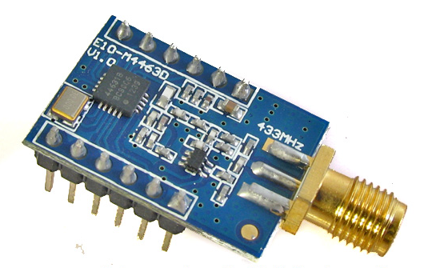
Description:
E10-M4463D-SMA is a middle power 433MHz frequency wireless transceiver module. It has features of high performance, long distance and high air rate. It adopts original SI4463-B1B or SI4438-B1C chip, which is industrial.

Specification:
NO. | Parameter Name | Parameter Details
1 | Module size | 16.6 * 24.1 mm
2 | source | all imported，origin : United States, Japan
3 | Production | machine stickers
4 | Interface | 1.27mm SMD type, you can use the universal plate and DuPont line
5 | Supply Voltage | 1.8V-3.6VDC
6 | communication level | 0.7VDD-3.6VDC，VDD is modules’voltage
7 | measured distance | 2100m@1K，condition：city,in open area,30℃,cloudy
8 | Maximum Power | 20dBm，about 100mW
9 | air rate | 0.123K - 1MBPS (adjustment via software)
10 | shutdown current | About 30nA，test conditions：PD mode，SDN=1
11 | Power Level | -20 - +20dBmadjustable
12 | Transmission current | maximum peak is 80mA
13 | Receiving current | 10MA，condition：3.0VDC power supply
14 | Antenna type | 433M spring antenna/SMA built-in (_optional)
15 | interface | Standard. (SPI)0，maximum 10Mbps air rate
16 | Transmission length | Single data 1-64 bytes , supports dynamic length
17 | Receiving length | Single data 1-64 bytes , supports dynamic length
18 | RSSI | support
19 | Receiving sensitivity | -121dBm
20 | Working temperature | -30 - +85℃
21 | Working humidity | <90% relative humidity
22 | Storage temperature | -40 - +125℃
23 | Working frequency | 425MHz - 525MHz，software adjustable（module oscillator is 30MHz）
Application:
This module can be widely applied in high-speed wireless data transmission, remote acquisition, security alarm, power monitoring, intelligent household, robots, model aircraft , lighting control, intelligent buildings, medical equipment, wireless audio, VOIP applications, high-end toys, intelligent sports equipment, wireless sensor networks.

Pin:
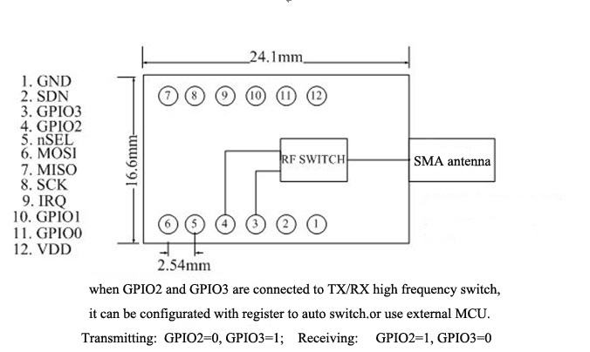

Pin Definition:
pin | Input/output | Description
GND |  | ground
SDN |  | pin，open in low level，
GPIO3 | output | Module data putput pin
GPIO2 | output | Module data output pin
nSEL | 输入 | SPI chip select pin，valid in low level
MOSI | 输入 | SPI data input pin
MISO | output | SPI data output pin
SCK | output | SPI clock pin
IRQ | output | Module interrupt pin
GPIO1 | output | Module data output pin
GPIO0 | output | Module data output pin
VDD |  | Power supply pin，1.8V-3.6V

Notice:
1,Analog Devices has a high frequency electrostatic sensitive nature , avoid human contact module of electronic components as possible . Our production process is fully implemented in accordance with the higher ESD standards.
2,When welding , soldering iron needs good ground , on request when mass production staff wear a grounded wrist strap cable .
3, greater impact on power quality module performance , please ensure that the power supply module has a small ripple , be sure to avoid frequent power dramatically shake . Recommend the use of π -type filter ( tantalum capacitor + inductor ) .
4,module using single-point ground grounding is recommended to use 0 ohm resistor , inductor or 10mH , separate from other parts of the circuit ground reference.
5,module antenna mounting structure has a greater impact on module performance , be sure that the antenna exposed , the best vertical. When the module is installed in the chassis interior , you can use high-quality antenna extension cable will extend the antenna to the outside of the case . Antenna must not be installed inside the metal shell , will lead to the transmission distance significantly weakened.
6,same product if there are other internal band wireless devices , due to the possibility harmonic interference , please increase as much as possible with the linear distance between the module and the possible use of metal materials to separate the two .
7,If the existence of a crystal near the location of the module circuit board, increasing as much as possible with the linear distance between the crystal , quartz crystal as far as possible with a metal shell package , crystal wiring should be a " floor " approach to the parcel.

How to use:
The single chip micromputer connect to SCK、MISO、MOSI、nSEL，the rest GPIO0-GPIO1can be used tp output data. GPIO2 and GPIO3 must be setted into special mode, whichthe single chip micromputer can’t control.

Common problems:

Communication distance is too short
- 433 m frequency band because of its physical properties When linear communication obstacles, communication distance will shorten different barrier properties, the attenuation degree of inconsistency
- Temperature and humidity, co-channel interference, packet loss rate will lead to improved communication.
- There are metal objects near the antenna, will absorb part of the wireless signal.
- Register power setting, rate setting. The faster the rate, the closer.
- Antenna can not be placed in a metal case, the decay is very serious.
- Module fever, easily damaged.
- Check the power supply to ensure that between 1.8V-3.6V.
- Check the power supply stability, does not significantly fluctuate frequently.
- Ensure the installation process antistatic operation. High-frequency electrostatic sensitive devices.
- Communication lines can not use 5V level.

